Special Publication No. 12
Guidebook No. 27

Guide to Field Trips
for
Association of American State Geologists
109th Annual Meeting,
Branson, Missouri, June 11–14, 2017

Editors
Jerry L. Prewett, Carey S. Bridges, and Larry D. Pierce

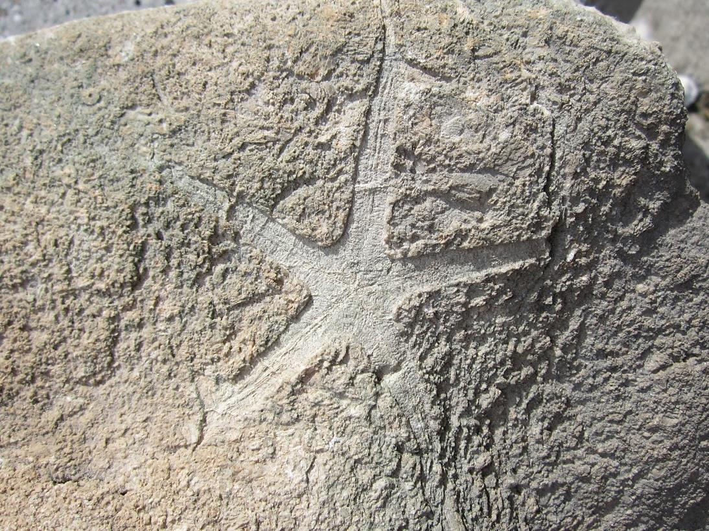

Special Publication No. 12
Guidebook No. 27

Guide to Field Trips
for
Association of American State Geologists
109th Annual Meeting,
Branson, Missouri, June 11–14, 2017

Editors
Jerry L. Prewett¹, Carey S. Bridges², and Larry D. Pierce³
¹Deputy Director and Assistant State Geologist, ²Director of Geological Survey Program, ³Chief of Geologic Resources Section
Missouri Geological Survey

July 2017


MISSOURI GEOLOGICAL SURVEY
Joe Gillman, Director and State Geologist

Front Cover Photograph — Starfish fossil, tentatively identified as Compsaster formosus, was found in 2016 by Conco employee Jacci Gamble in weathered slab of Mississippian Osagean Burlington-Keokuk Limestone on Conco Quarries, Inc., Graystone Quarry property in northwestern Greene County, Missouri. It measures 2.6 inches from tip of arm pointing 10 o’clock to tip of arm pointing between 2 and 3 o’clock. The bottom exterior of the starfish is shown. Ambulacral grooves and mouth are closed. Specimen is in the possession of Jacci Gamble.

Library of Congress Control Number: 2017940097
Missouri Classification No. MoDNR. Ge 21:12

Prewett, Jerry L., Bridges, Carey S., and Pierce, Larry D., editors, 2017, Guide to field trips for Association of American State Geologists 109th Annual Meeting, Branson, Missouri, June 11–14, 2017. Missouri Department of Natural Resources, Missouri Geological Survey, Special Publication No. 12, 60 p., 28 figs.

The Department of Natural Resources does not discriminate against anyone on the basis of race, color, national origin, religion, age, sex, disability, sexual orientation or veteran status. If anyone believes he or she has been subjected to discrimination for any of these reasons, he or she may file a complaint with either the Department of Natural Resources or the Office of Equal Opportunity, U.S. Department of the Interior, Washington, D.C., 20240.
CONTENTS

Pre-Meeting Field Trip, June 11, 2017 …………………………………………………………......... 1

First Leg of Road Log — Branson to Springfield, Missouri ……………………...………....... 3
STOP 1 — Sequiota Park, Cave and Spring …………...…………………....................... . 7

Second Leg of Road Log — Springfield to Phenix, Missouri ………………………………. 11
STOP 2 — Phenix Marble Quarry ................................................................................... 13

Third Leg of Road Log — Phenix to near Battlefield, Missouri ……………..….…...……... 22
STOP 3 — Wilson’s Creek National Battlefield …………………………....................... 23

Fourth Leg of Road Log — Return to Branson, Missouri …………………………...…........ 26

□ □ □ □ □

Mid-Meeting Field Trip, June 13, 2017 ……...………………………...………………............…...27

First Leg of Road Log — Branson to Silver Dollar City, Missouri ……………..…….......... 29
STOP 1 — Marvel Cave Park ….....…………………....……………………….................... . 30

Memorial — Jerry D. Vineyard (1935–2017) ……………………………………................... 34

Second Leg of Road Log — Silver Dollar City to Top of the Rock, Missouri ……………. 34
STOP 2 — Sinkhole Excavation at Top of the Rock ................................................. . 35

Third Leg of Road Log — Return to Branson, Missouri ………………….……..………....... 36

□ □ □ □ □

Post-Meeting Field Trip, June 15, 2017 ……...………………………...………………...........….. 37

Geology Float Trip on Buffalo National River, Northern Arkansas …........................ 39

□ □ □ □ □

Compendium of References Cites ……...……………….......................……………............…… 49

□ □ □ □ □
Appendix ……...……………………….............................................................………………...........….. 51

Generalized Geologic Map of Missouri ……............................................………......……....... 52
Mineral Resources in Missouri ……...……………………………………………….......……....... 53
Missouri Groundwater ……...…………..........................................................................…….... 54
Major Structural Features of Missouri ……...…………......…………………………………....... 55
Physiographic Regions of Missouri ……...…………......……………………………………....... 56
Surface Elevation Map of Missouri ……...…………......………………………………….…....... 57
Surficial Materials Map of Missouri ……...…………......……………………………………........ 58
Topographic Relief Map of Missouri ……...…………......………………………………...…....... 59

■ ■ ■ ■ ■
LIST OF FIGURES

Figure Page

1 Map for Pre-Meeting Drive Route Legs and Stops ............................................................................. 2
2 Chestnut Ridge section exposed in road cut on U.S. Route 65 at mile marker 24.6 ………………….. 4
3 Woods Fork segment of Highlandville fault system exposed in U.S. 65 road cut between
mile markers 29.6 and 29.8 ………………………………………………………………………………….. 5
4 Entrance of Sequiota cave in southeast portion of Springfield, Greene County, Missouri .................. 7
5 Dye traces…in southeastern Springfield, Greene County, Missouri ……………………………............ 8
6 Red clay and siltation in Sequiota cave in 2007 …………………………….......................................... . 9
7 Sinkholes that caused red clay and siltation event at Sequiota cave in 2007 ………………………… 10
8 Phenix limestone quarry is located in northwestern Greene County, Missouri ………………………. 13
9 Phenix quarry during late 1920s …………………………………………………………………………… 16
10 Present-day Phenix Marble Co. ……………………………………………………………………………. 19
11 Geologic map of Phenix quarry and vicinity in northwestern Greene County, Missouri …………….. 20
12 Generalized stratigraphic column for Phenix quarry and surrounding region in
northwestern Greene County, Missouri ……………………………………………………….………...... 21
13 Conceptual model that invokes estavelles and fluctuating water volume to explain
observed behavior of surface water and shallow groundwater between Wilson’s Creek
and Rader Spring …………................................................................................................................ 24
14 House claimed by sinkhole collapse at Nixa, Missouri, in 2006 ………………………………………... 26
15 Map for Mid-Meeting Drive Route Legs and Stops ……………………………………………………… 28
16 Map of Marvel Cave, Stone County, Missouri ……………………………………………………………. 30
17 Cross sectional view of Marvel Cave alongside geologic column for regional stratigraphy ………… 32
18 Sinkhole at Top of the Rock in southwestern Taney County, Missouri, as it looked after
excavation of a considerable amount of surficial material ……………………………………………… 35
19 Generalized map of the Top of the Rock area, southwestern Taney County, Missouri …………….. 36
20 Map for Post-Meeting Drive Route from Branson to Buffalo National River ………………………….. 38
21 Map showing 5.5-mile-long float trip route on the Buffalo National River …………………………….. 39
22 Physiographic map showing location of the 153-mile-long Buffalo River ……………………………... 40
23 Stratigraphic column for bedrock that crops out along the Buffalo National River …………………… 41
24 Bedrock formations exposed in bluff at Tyler Bend ……………………………………………………… 42
25 Park Service placed tree revetments to mitigate erosion of unconsolidated
Quaternary bank deposits ………………………………………………………………………………….. 43
26 Bluff at Grinders Ferry showing reentrant ………………………………………………………………… 44
27 Fallen boulders of upper Boone Formation resting in river at Shine Eye Bend ………………………. 45
28 Silurian (probably Lafferty) limestone is angularly overlain by St. Joe Limestone Member
of Boone Formation in the upstream portion of Shine Eye Bluff ……………………………………….. 46

LIST OF TABLES

Table Page

1 Weight-percent chemical analyses for samples of Phenix limestone …………………………………. 20
2 Lithostratigraphic nomenclature: Arkansas vs. Missouri ………………………………………….......... 41

Pre-Meeting Field Trip, June 11, 2017

■ ■ ■
First Leg of Road Log — Branson to Springfield, Missouri
STOP 1 — Sequiota Park, Cave and Spring
□ □ □
Second Leg of Road Log — Springfield to Phenix, Missouri
STOP 2 — Phenix Marble Quarry
□ □ □
Third Leg of Road Log — Phenix to near Battlefield, Missouri
STOP 3 — Wilson’s Creek National Battlefield
□ □ □
Fourth Leg of Road Log — Return to Branson, Missouri
■ ■ ■

Figure 1. Map for Pre-Meeting Drive Route Legs and Stops
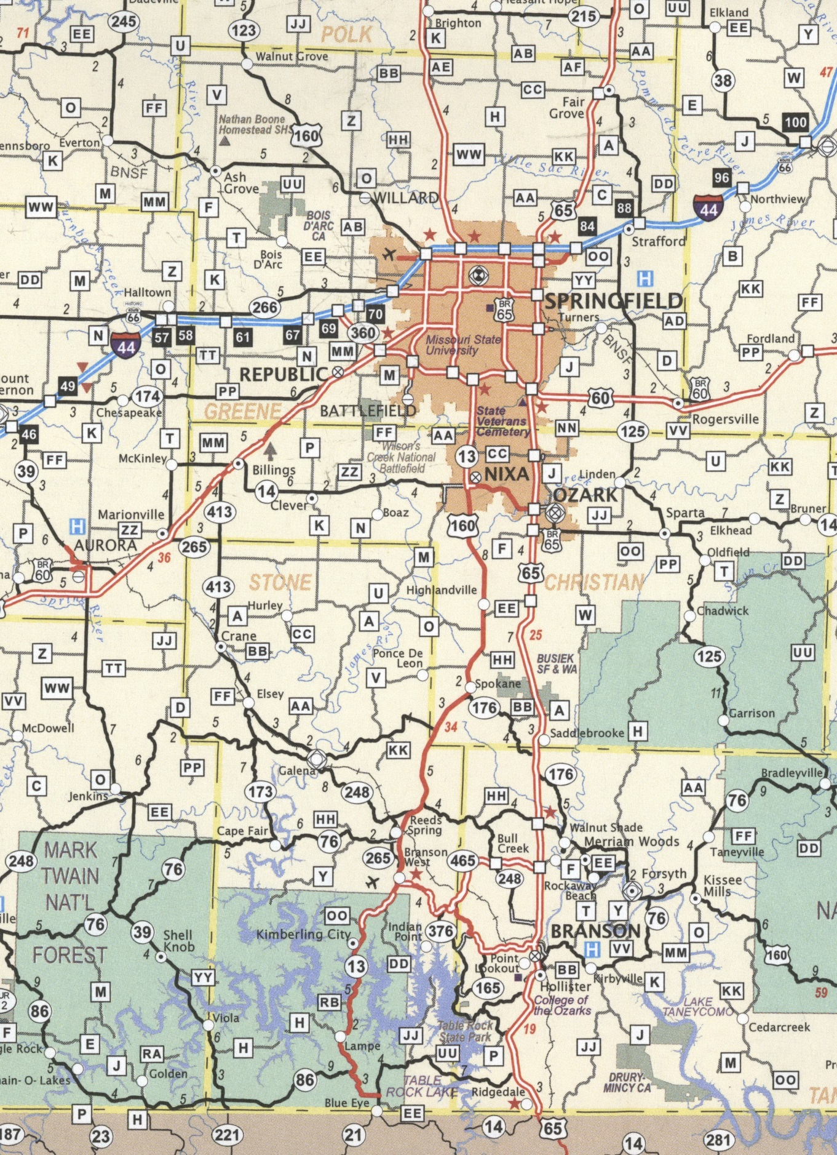
START—END
146 mi. Total
LEG 4
LEG 4
LEG 2
LEG 2
LEG 3
LEG 1
STOP
STOP
STOP
3
2
1
10 miles
First Leg of Road Log — Branson to Springfield, Missouri
by
Staff of the Missouri Geological Survey

Numbers in left column are travel distances in statute miles. Red numbers are mile markers alongside federal routes. Features pointed out in this log can be viewed using Google Street View and associated aerial imagery.
Turn right out of Hilton Branson Convention Center onto South Sycamore Street and head north for very short distance to intersection with East Main Street.
0.0 Turn right and head east on East Main Street for very short distance.
0.05 Stop at railroad crossing. Turn left and head north on Branson Landing Boulevard. Get in right lane and stay there. Go straight through traffic light at Commercial Street intersection. Cross bridge over White River. Enter traffic circle (aka roundabout) and proceed uphill on Branson Landing Boulevard. Stay in right lane.
1.0 Turn right onto U.S. Route 65 and head north towards Springfield.
1.3 12.6. First mile marker seen along east (right) side of highway. For next 10 miles, essentially flat- lying, variably cherty and silty, Ordovician Ibexian Cotter Dolomite is exposed in road cuts. Cotter thickness ranges from 100 to 300 feet in this southwestern portion of Missouri (Thompson, 1991, p. 50). See generalized state geologic map in Appendix.
4.8 16.0–16.2. Interchange with Missouri Route 465 (aka Mountain Highroad). Flat-lying Cotter Dolomite is exposed in road cuts on left side of road.
Regarding this location, Davis (2003, p. 69) stated, “On Route 465 approximately 330 yards west of the intersection with Route 65…a cave was found while a rock cut was being excavated [in the late 1990s]. Named the Highroad Horror Cave, this cave dropped 50 feet under the road from a six-foot by two-foot entrance on the ditch line of the route. A small stream issues from an area just under the cavern entrance with approximate discharge of 5 gallons per minute. This stream flows down the sides of the pit becoming a small waterfall about 8 feet below the entrance to the pit. As the pit does not seem to be endangering the highway, the current drainage path was preserved, and the project continued….”
6.6 17.8–18.0. Solution-widened joints in Cotter Dolomite are exposed in cuts on both sides of highway. A particularly wide one is located just north of the bridge that overpasses the highway and which is very close to and parallel to a northwest-trending overhead powerline. Note that the widened joint has been walled off with carefully placed blocks of local stone so as to blend fairly well with the horizontal layering of adjacent wall rock.
6.9 18.2. Another solution-widened joint in Cotter Dolomite. This one, however, appears to trend northeast, and it has likewise been walled off with stone blocks.
7.3 18.4–18.8. Interchange with U.S. Route 160. Look back towards 5 o’clock to see the “little buttes” that were sculpted out of Cotter Dolomite during excavation for this interchange.
8.4 19.6–19.8. Cotter Dolomite is exposed in road cut. On the left is solution-widened joint filled with red clay that is actively eroding out and forming a small fan deposit at the base of the cut. On the right and little farther north, the same joint, which trends northeast, has been walled off with blocks of local stone.
8.8 20.0–20.2. Cross bridge over Bear Creek and begin ascent of Ozark Escarpment, which is the dissected edge of the Springfield Plateau (see physiographic map in Appendix).
10.2 21.4–21.6. Thick, reddish, clayey residuum can be seen overlying Cotter Dolomite in road cuts.
10.4 21.6–21.8. Intersection with Missouri Route 176 East. Stay on U.S. Route 65.
11.3 22.6. Intersection with Missouri Route 176 West. Stay on U.S. Route 65.
11.7 23.0. Flat Springfield Plateau can be seen forming the north horizon (see physiographic map in Appendix).
12.0 23.2–23.4. Leave Taney County and enter Christian County.
23.6. Localized deformation in otherwise undisturbed strata can be seen in road cut. Plymate et al. (2004, p. 56) stated, “…road cut on the east [right] side of the highway exposes a small thrust fault in the lower Ordovician Cotter Dolomite…. The fault plane can be traced for only a few tens of feet before it merges into bedding planes. An interesting feature…is that the terminus or leading edge of the overriding block can be seen in cross-section. The timing of thrust faulting…is unknown, but it is possible that it is related to distal compression during the Ouachita Orogeny.”
13.0 24.2–24.4. Cross bridge over Camp Creek. Sign indicating “City Limit Saddlebrooke” on east (right) side of road.
13.3 24.6. See Figure 2. Large, four-tiered road cut on east (right) side of road. Ordovician Ibexian Cotter Dolomite, having 110 feet thickness, comprises the lower three tiers, with the informally named “Swan Creek sandstone” of Cotter Dolomite forming the top several feet of the bottom tier at the south end of the cut. A very thin, Devonian-age, unconformity unit named Bachelor Formation resides on top of the third tier. The Bachelor is in turn unconformably overlain by 60 feet of Carboniferous Mississippian strata, comprising from bottom to top, Kinderhookian Compton Limestone, Kinderhookian Northview Formation (greenish), Osagean Pierson Limestone and Osagean Reeds Spring Formation. Plymate et al. (2004, p. 46) referred to this road cut exposure as the “Chestnut Ridge section.” It is more complete stratigraphically than any other section noted in this guidebook.
Tier 4
Bachelor
Compton
Northview
Pierson
Reeds Spring
C O T T E R
Swan Creek
Tier 2
Tier 1
Tier 3

Figure 2. Chestnut Ridge section exposed in road cut on U.S. Route 65 at mile marker 24.6. From Plymate et al. (2004, p. 47).

14.5 25.8. Mississippian Osagean Reeds Spring Formation exposed in road on west (left) side of road. The Reeds Spring is typically very cherty, with the chert characteristically segregated in layers.
15.2 26.2-26.8. Upper Cotter Dolomite exposed in road cuts.
26.8. Cross bridge over Woods Fork of Camp Creek.
15.7 26.8-27.2. Upper Cotter Dolomite exposed in road cuts.
16.1 27.4. Mississippian Kinderhookian Compton Limestone and Northview Formation (greenish) and Osagean Pierson Limestone exposed in road cut on east (right) side of road.
16.4 27.6–27.8. Thick, reddish residuum on both sides of road and intersection with Woods Fork Road.
16.7 28.0. Mississippian Osagean Reeds Spring Formation exposed on both sides of road.
18.4 29.6–29.8. Woods Fork segment of Highlandville fault system crosses the highway (see Figure 3). Vineyard and Fellows (1967, p. 13 and 16) stated, “The major fault exposed in these cuts strikes N. 55° W., is nearly vertical, and has breccia and gouge associated with it…. Strata on the north side of the fault [north end of cut on west (left) side of highway and all of cut on east (right) side of highway] have moved downward with respect to those on the south [the remainder of cut on west (left) side of highway]. The Northview Formation, displaced approximately 60 feet, is in contact with the Cotter Dolomite [at north end of cut on west (left) side of highway]. Numerous smaller faults, associated with the major fault, are present on the downthrown side [see right side of road]…. This faulting might be the southeastern extension of the Chesapeake fault.” It is probable that movement on this fault is dominantly strike slip.
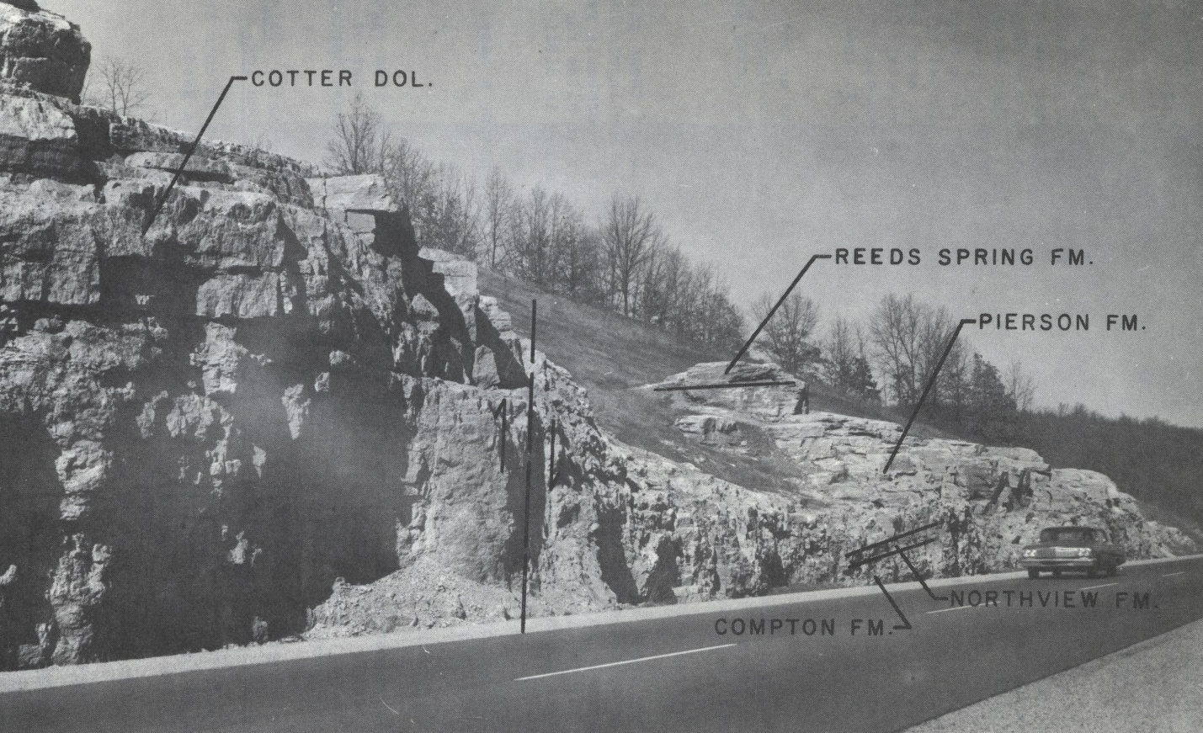

Figure 3. Woods Fork segment of Highlandville fault system exposed in U.S. 65 road cut between mile markers 29.6 and 29.8. View is towards northwest. This photograph was taken in the 1960s and shows what the exposure looked like before vegetation has masked many of the visual details. From Vineyard and Fellows (1967, p. 12).

30.4–30.6. Mississippian Kinderhookian and Osagean strata on east (right) side of road.
19.7 31.0. Atop Springfield Plateau, which is that part of southwestern Missouri where Mississippian Osagean Burlington Keokuk Limestone crops out, but which is typically occluded by a thick blanket of reddish, cherty residuum that was derived through in situ karst weathering of the limestone. The interface between residuum and underlying limestone exhibits marked cutter and pinnacle relief.
21.4 32.6–32.8. Interchange with Missouri Route EE.
25.1 36.2–36.6. The peaks of Burlington-Keokuk pinnacles are peeking through residuum along west (left) side of highway.
25.7 36.8–37.2. Interchange with Missouri Route F.
26.1 37.2–37.6. Pinnacles of Burlington-Keokuk Limestone and cutters of residuum are exposed in road cut on west (left) side of highway.
26.6 37.8–37.9. Cross bridge over Finley River.
27.0 38.2–38.4. Interchange with Missouri Route 14.
31.3 42.5–42.6. Burlington-Keokuk Limestone exposed in road cut on west (left) side of road.
31.5 42.8. Leo Journagan Construction Co., Inc., Ozark Quarry in Burlington-Keokuk Limestone and underlying Mississippian limestone units visible from 3 to 4 o’clock. The Springfield Plateau offers abundant opportunity for the development of rock quarries in Burlington-Keokuk Limestone. Lime kilns were present on the Springfield Plateau in the past, the last one—in Springfield proper— having shut down in 2007.
31.6 42.8–42.9. Burlington-Keokuk Limestone exposed in road cut on west (left) side of road.
32.4 43.6–43.7. Burlington-Keokuk Limestone exposed in road cut on west (left) side of road.
32.7 44.0–44.9. Burlington-Keokuk Limestone of 196 feet thickness is exposed in deep road cut, the lower 142 feet of which Thompson (1986, p. 90) designated as the reference section for Burlington Limestone in Missouri. He (op. cit.) also assigned the uppermost 54 feet of this road cut to Keokuk Limestone, which is replete with a 3-foot thickness of the Short Creek Oolite Member that is positioned 8 feet below the top of the section. For most purposes, it is usually convenient to lump these two units together into Burlington-Keokuk Limestone (Thompson, 2001, p. 42).
33.6 44.9–45.0. Cross bridge over Lake Springfield that was created by damming the James River.
34.2 45.2–46.0. Interchange with U.S. Route 60. Stay on U.S. 65.
35.3 46.6. Burlington-Keokuk Limestone on both sides of highway.
35.8 47.1. Karst-pinnacled Burlington-Keokuk Limestone and clay-filled cutters on both sides of highway.
36.3 47.5. Exit right off of U.S. 65 at interchange with Battlefield Road. Turn left at traffic signal and head west on Battlefield Road.
37.2 Turn left onto South Lone Pine Avenue and head south.
38.0 Turn left into Sequiota Park.

■ ■ ■

STOP 1 — Sequiota Park, Cave and Spring
by
Douglas R. Gouzie
Missouri State University, Springfield, Missouri

Introduction
Sequiota Park is a popular park in the metropolitan Springfield urban area. The City of Springfield and surrounding Greene County share a merged Parks department, the Springfield-Greene County Park Board (the Park Board). Like many parks departments around the nation, the Park Board has developed and manages a number of properties to address varying interests and uses in the community, including over two dozen caves within their park system. One of the older parks in the system is Sequiota Park in the southeastern portion of the city.

History
Sequiota Park had a history long before it was made a unit of the Springfield park system. The park was originally in the village of Galloway, a community named for Major Charles Galloway, who owned the spring and surrounding land after the Civil War (Vineyard and Feder, 1982). Major Galloway ran a general store in the area and used one of the caves (now known as “Walkway-All-The-Way Cave”) in the park as a cool-storage room and store (Vineyard and Feder, 1982). Some historical reports (Anon., 2016) identify ownership by various farmers and landowners as early as the late 1830s. Quite visible when one visits the cave is that a portion of the cave entrance appears to have been removed by quarrying (Figure 4); however, it is unclear when that quarrying occurred.

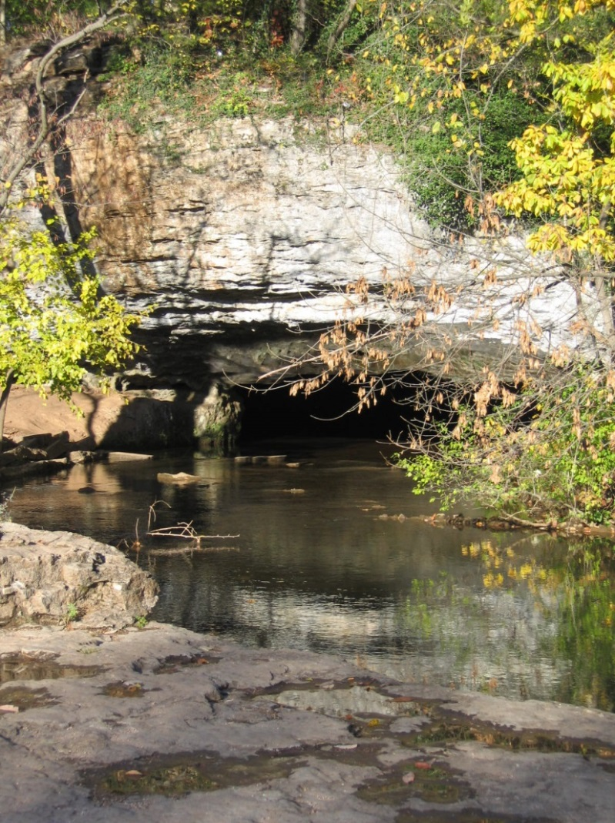

Figure 4. Entrance of Sequiota cave in southeast portion of Springfield, Greene County, Missouri. (D.R. Gouzie photograph)
The main Sequiota cave is located in a bluff of the lower portion of the Burlington-Keokuk Limestone that is roughly 25 feet high and runs somewhat continuously along the eastern edge of the Galloway Creek valley. The cave has been mapped eastward into the hillside about 950 feet before it splits into two passages, each with streamflow. Bretz (1956) reported that the southeastern passage tended to contribute muddy water while the northeastern passage tended to contribute clear water. The result of these two passages is that the main cave has a perennial stream issuing from the entrance, and the outflow has been reported as high as 11 million gallons per day (Bullard et al., 2001). Several dye traces have been reported in the area (Missouri Geological Survey, 2017), with most traces identifying sinkholes and losing streams north of Sequiota Park as source areas for the water in the cave (see Figure 5).

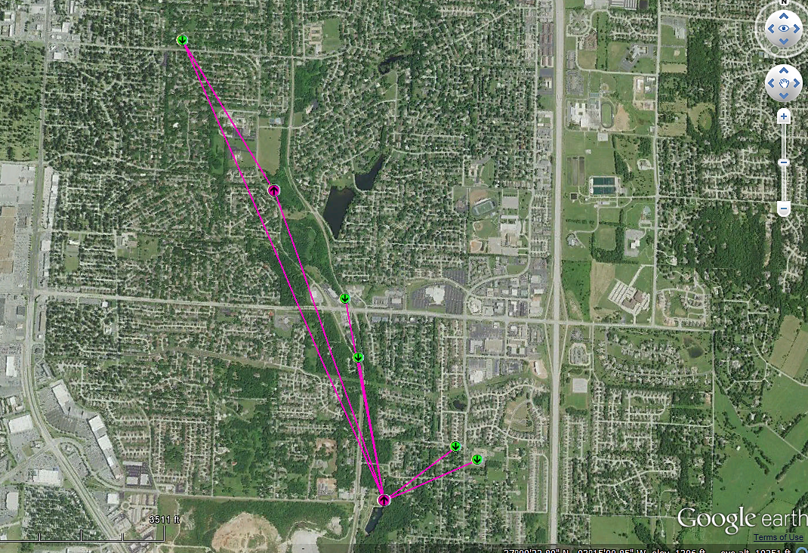
1 MILE
N
Cave at
Sequiota Park

Figure 5. Dye traces showing migration routes of water from dye injection points (green dots) to dye recovery points (magenta dots) along hypothetical straight-line subterranean pathways (magenta lines) in southeastern Springfield, Greene County, Missouri. Graphic generated on-line using GeoSTRAT application of Missouri Geological Survey (2017).

Multiple accounts identify the cave in Sequiota Park as having an earlier name of Fisher’s Cave (Bretz, 1956) and possibly some other names related to various landowners through the years. Sometime in the late 1800s, at least one landowner started giving boat tours of the cave and improving the area around the cave. In fact, the area became so popular that the Frisco Railway is reported to have offered weekend excursion trains from Springfield to Sequiota Park from 1914 to1917 (Anon., 2016).
Around 1920, the State of Missouri bought the property and began to develop the state’s second fish hatchery (the first one was in Forest Park, near St. Louis) on the site, making use of the cool water from the cave. The state fish hatchery operated at the site until 1959, at which time it was moved south to its present location near Table Rock Dam in Taney County. At that time, the state donated the Sequiota property to Springfield for a public park, and it has remained in that status ever since.

Features and Issues
One of the earliest environmental management issues reported for Sequiota cave was widespread concern in the 1970s that the cave water smelled like raw sewage and that possibly the water was essentially sewage from septic tanks in housing developed to the east of the cave. These concerns led to an investigation by Mr. Tom Aley in 1973, who reported injecting dye into the urinals in the boy’s restroom of Sequiota Elementary School and detecting that dye soon after in detectors in the cave spring (Bullard et al., 2001). After many other studies and much planning, sewer lines were installed in the housing area east of the park in the early 2000s. One potential reason for the lengthy time to install sewers was the geologic nature of the Burlington-Keokuk Limestone in that area. In most instances, sewer mains being run along various streets in the area encountered pinnacles of limestone which were solid enough to resist simple bulldozing or trenching methods and therefore required blasting. The need for explosives in certain areas and locations made planning and budgeting for the sewer project difficult, let alone the actual construction.

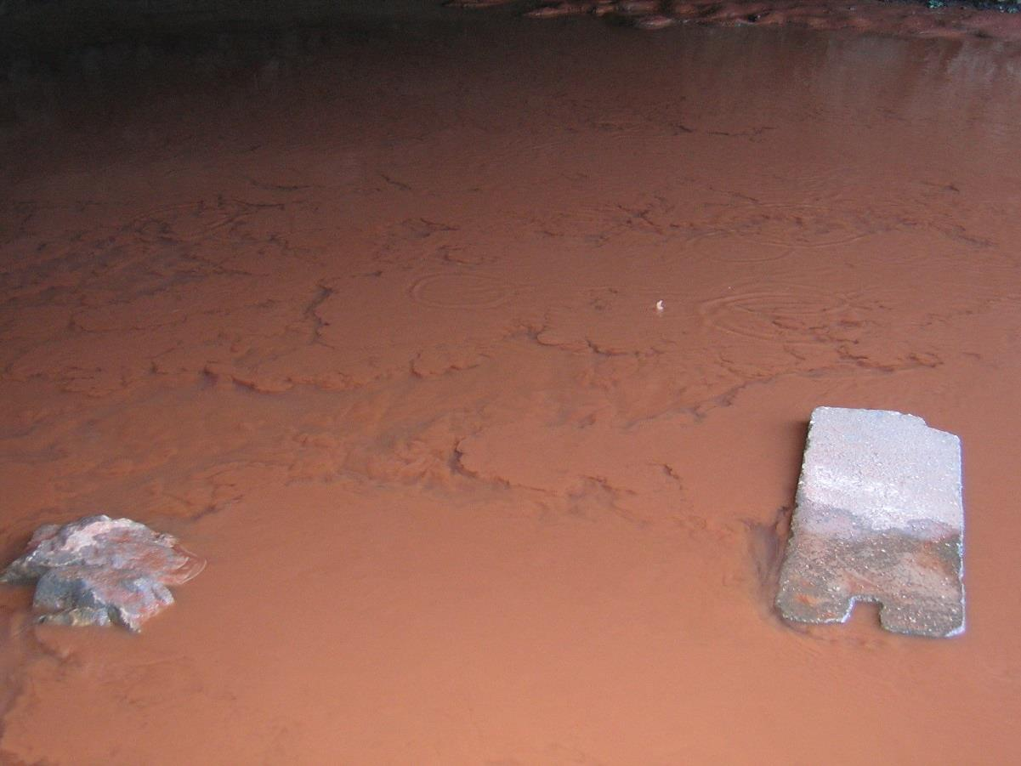

Figure 6. Red clay and siltation in Sequiota cave in 2007. (D.R. Gouzie photograph)

Red Water Discharge from Main Cave (2007)
In 2007, citizens enjoying the park reported that the water coming from Sequiota cave was running a deep red color and those reports prompted an investigation (see Figure 6). One of the first steps was to consider the possibility that either the Missouri Geological Survey or Missouri State University was conducting a dye trace in the area (given the similarity in color to Rhodamine WT dye, which is also deep red in highly concentrated solutions). Upon further investigation, it was determined that an undeveloped parcel of property to the east of the cave had experienced a sinkhole incident and the red color in the water was due to a large pulse of red clay and silt being flushed into the southeast passage of the cave from the sinkhole (see Figure 7). In fact, it turned out that the sinkhole event was related to a broken water distribution line that sent a significant amount of water into the sink, and that water facilitated the flushing of sediment. It is a matter of speculation whether the water line broke and caused the sinkhole or whether some shifting during the initial stages of the sinkhole caused the water line to break. The net result was a compound sinkhole where an older, existing sinkhole grew two smaller side-sinkholes with the broken water line running through the side sinks. Interestingly, the water line was part of the older Galloway Village water supply. Because that system had been added to Springfield’s public water supply as a loop tied in at one location to Springfield’s main feeder, the broken line caused water to run out of both sides of the loop line until Springfield’s main utility provider noticed the amount of water flowing through that portion of town and investigated, thus finding both the water line break and the new side-sinkholes.

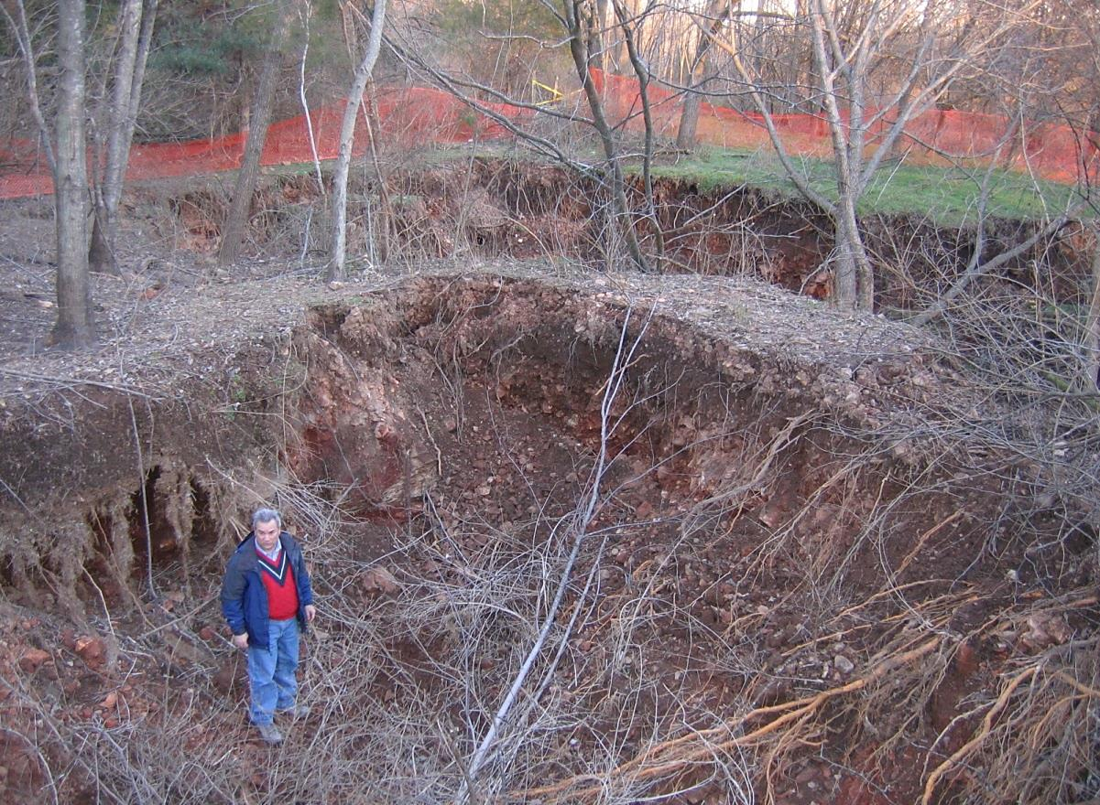

Figure 7. Sinkholes that caused red clay and siltation event at Sequiota cave in 2007. Yellow arrow points to old, severed water line pipe. (D.R. Gouzie photograph with Gouzie for scale)

Ongoing Bat Hibernaculum Issues
One ongoing issue posed by the popularity of Sequiota Park is that of trespassers entering the main cave. The main Sequiota cave has been identified as a hibernaculum for a maternal colony of bats and therefore the Park Board must make efforts to see that the bats are not disturbed under wildlife protection laws. However, the open nature of the park and the long-term popularity of the park have made it difficult to keep trespassers out of the cave. Multiple signs are posted at the entrance of the cave. There is a 10-foot-deep pool of water, left over from the early cave tour days, just inside the entrance that should prevent waders from entering far enough to disturb the bats. However, unless the park is secured with a gate or fencing, occasional trespassers are caught in the park late at night, after the daily 11 p.m. closing time. The Park Board has contacted Missouri State University and local caving clubs to investigate the possibility of installing a gate at the entrance to Sequiota cave. However, the type of gate appropriate for maternal bats and the size of the main entrance make such a gating effort impractical. The Park Board continues to explore ways to educate the public, offering an educational boat tour of the cave once per year, and increasing ranger patrols in efforts to best manage this cave resource.

■ ■ ■
Second Leg of Road Log — Springfield to Phenix, Missouri
by
Staff of the Missouri Geological Survey

Numbers in left column are travel distances in statute miles. Red numbers are mile markers alongside federal routes. Features pointed out in this log can be viewed using Google Street View and associated aerial imagery.
0.0 Turn right out of Sequiota Park onto South Lone Pine Avenue and head north.
0.8 Turn right onto Battlefield Road and head east.
1.7 Turn left onto U.S. Route 65 and head north.
2.0 48.0. First mile marker seen along east (right) side of highway.
3.2 49.2. Pass beneath East Sunshine Street.
4.7 50.6–50.8. Tops of Burlington-Keokuk Limestone pinnacles exposed on both sides of highway.
5.3 51.2–51.4. Tops of Burlington-Keokuk pinnacles exposed on east (right) side of highway.
52.2–52.4. Tops of Burlington-Keokuk pinnacles exposed on both sides of highway.
6.8 52.8. At 2 o’clock is surface expression of Springfield Underground, a company that mines Burlington-Keokuk underground for the dual purpose of producing crushed stone and creation of marketable underground space to the tune of 2.5 million square feet. The mine is 100 feet below the surface and is in two parts that are connected by tunnels beneath the highway. Temperature is reportedly a nearly constant 62°F. Ventilation shaft is visible in flat field on west (left) side of road.
7.3 53.2–53.4. Burlington-Keokuk pinnacles exposed on both sides of highway.
7.8 53.8. Exit right in left lane of exit ramp, then take “West Interstate 44 Joplin” option at the fork in the road.
8.6 82.0. First mile marker seen along the north (right) side of the Interstate highway.
9.9 80.8–80.7. Burlington-Keokuk exposed on both sides of highway.
10.2 80.4. Glenstone Avenue overpass.
10.3 80.4–80.3. Burlington-Keokuk exposed on both sides of highway.
10.6 80.1–79.9. Burlington-Keokuk exposed on both sides of highway.
11.5 79.3–79.0. Burlington-Keokuk pinnacles exposed on both sides of highway. The intervening cherty, red clay cutters are covered by grass,
12.8 77.8. Missouri Route 13 overpass.
13.1 77.7–77.3. Burlington-Keokuk pinnacles and underlying laterally continuous Burlington-Keokuk bedrock exposed on both sides of highway.
14.8 75.8. Exit right off of Interstate 44 and travel up exit ramp.
15.1 Turn right onto Missouri Route 160 and head northwest.
16.8 Passing through two large shallow sinkholes.
17.2 Burlington karst cutters and pinnacles on both sides of road.
18.5 Willard city limit sign. Conco Quarries, Inc., Graystone Quarry crushed limestone stockpile visible on horizon straight ahead. The starfish pictured on the front cover of this book was found on the Graystone Quarry property.
18.9 Truck exit road from Conco Quarries scale house on right.
19.8 Traffic signal at intersection with Hunt Road (Farm Road 103). Go straight through intersection. Phenix Marble Company fabrication shop seen at 5 o’clock.
20.5 Traffic signal at intersection with State Route 160 Business. Stay on State Route160. Burlington- Keokuk Limestone on left side of road.
20.7 Traffic signal at intersection with Miller Road. Go straight through intersection.
21.2 Traffic signal at intersection with Missouri Routes AB and Z. Go straight through intersection, staying on Route 160.
23.5 Exit right onto Missouri Route 123 and travel north.
28.8 Turn left onto West Farm Road 36 and travel west about 0.2 miles to stop sign at intersection with North Farm Road 53. Go straight through intersection and head west on West Farm Road 36.
30.9 Cross bridge over creek.
31.0 Turn right and travel north on North Farm Road 45 to Phenix.
Continuous lime kilns on west (left) side of road. They were built in 1888 alongside a railroad that was laid in 1884 or 1885 and which was pulled in 1941.
31.3 Turn left into Phenix marble quarry. The large stone building on the left was built in 1921 or 1922 and served as the electrical powerhouse for the quarry until the Great Depression.

■ ■ ■

STOP 2 — Phenix Marble Quarry

by
David L. Bridges and Patrick S. Mulvany
Missouri Geological Survey, Rolla, Missouri

Introduction
Phenix quarry (Figure 8) was founded 130 years ago. The main product through the years has been Burlington-Keokuk dimension limestone that has been marketed under different names, with Napoleon Gray Marble being the hallmark stone. The stone has been used for at least 124 major installations, both exterior and interior, in the United States and several other countries. Notable installations in the United States include Missouri State Capitol, Jefferson City, MO; Bank of America Building, New York, NY; New York Stock Exchange, New York, NY; Standard Oil Building, New York, NY and Federal Reserve Bank Building, San Francisco, CA; National Academy of Sciences Building, Washington, D.C.
Phenix quarry has been operated by various business enterprises over the years and has experienced upturns and downturns caused by economic climate (the Great Depression, in particular), competition from reinforced concrete and artificial stone products, and shifts in the popularity of marble as an architectural and ornamental building material. Dimension stone production ceased entirely in 1986, but was recently started anew by Conco Quarries, Inc., who is hosting this stop.
The purpose of this article is to summarize the history and geology of the Phenix quarry.

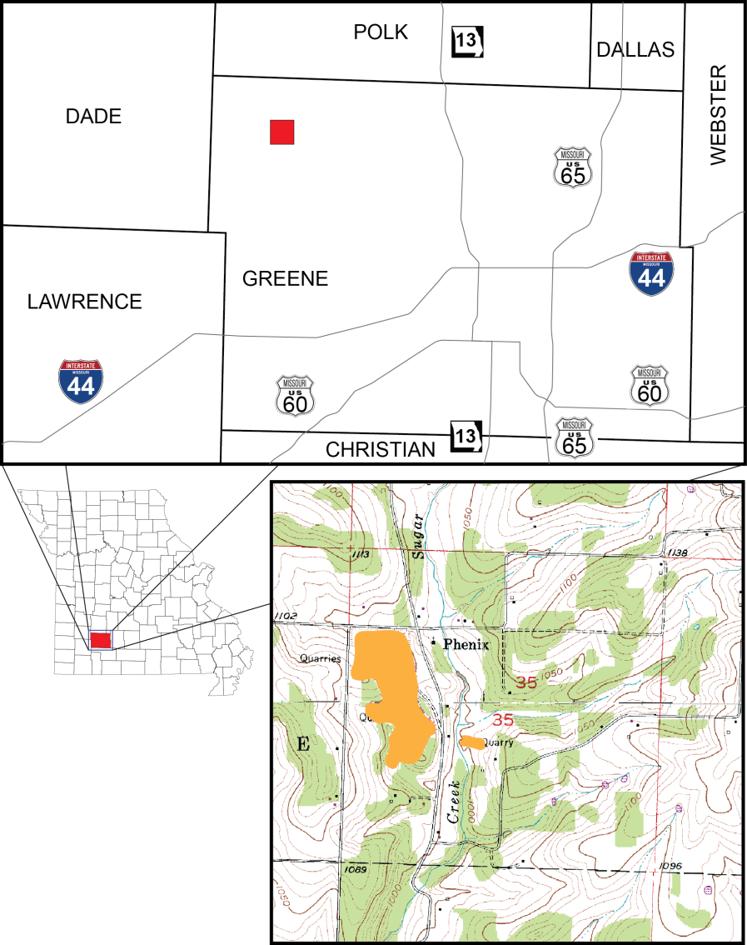
N
25 MILES
I MILE
Phenix Quarry
SPRINGFIELD

Figure 8. Phenix limestone quarry is located in northwestern Greene County, Missouri. Area shaded orange on portion of U.S.G.S. 7.5-minute quadrangle map in lower right indicates extent of rock removal and disturbance in square-mile section 35.
Beginning Years: 1884 to 1888
The story of Phenix begins in September 1884 with the charter of the Kansas City, Clinton and Springfield Railroad, which was a spur of the Kansas City, Ft. Scott and Memphis Railroad. Construction for the railroad commenced in late 1884. It was during late 1884, or early 1885, that blasting for the right-of-way revealed a deposit of high-quality Burlington-Keokuk Limestone at Phenix.
Meanwhile, an Irish immigrant and lime burner named Patrick Mugan was operating a lime kiln that he built in 1881 just east of Springfield on an exposure of Burlington-Keokuk. Sensing a new business opportunity close at hand, Mugan purchased property at Phenix on June 11, 1888. He purchased two adjoining parcels later that year.
Working in association with Calvert R. Hunt of Kansas City in a business arrangement that is not clearly understood from a reading of historical documents, Mugan built two continuous-feed lime kilns alongside the rail at Phenix, presumably between June 11 and December 19, 1888. It is not clear whether Mugan actually operated these kilns. Furthermore, historical records suggest that production of unfinished dimension stone at Phenix for bridge piers, pier facings and monuments was initiated, probably by Hunt, either shortly before or during this period of time. For sure, things were moving along quickly.
On December 19, 1888, Mugan sold all interests in his lime kiln operations at Springfield and Phenix to Hunt for $15,000. That same day, Hunt sold half interest in the entire Springfield and Phenix operations to Robert F. Harrison of Kansas City for $10,000. Historical records of these transactions make it perfectly clear that Hunt and Harrison were the owners of the Springfield and Phenix Lime and Stone Company.

Growth Years: 1889 to 1910s
In April 1889, Hunt and Harrison contacted the Waddell & Jenkins engineering firm in Kansas City regarding the structural integrity of their rock for dimension limestone. After receiving a favorable assessment of the stone, Hunt and Harrison purchased a steam-powered channeling machine and were cutting blocks for dimension stone by the end of 1889.
On January 2, 1891, Hunt and Harrison transferred their holdings to the Phenix Stone and Lime Company, which they had incorporated the year prior.
On August 24, 1892, Missouri Geological Survey geologist, H.A. Wheeler, while riding the Kansas City, Ft. Scott and Memphis Railroad through Phenix, noted in his field book (MGS #211, p. 15) that Phenix consisted of a train “depot”, a “hotel” and a “few houses” located “by a limestone quarry and kilns.” Shepard (1898, p. 201) commented that the stone is “worked only by sawing, the jar and strain produced by blasting, is avoided” and that the “uniform weight of this rock is remarkable, varying but a pound or two from 164 pounds to the cubic foot.”
Six years later, Buckley and Buehler (1904, p. 163–164) wrote the following summary statement based on their on-site inspection of Phenix:
“This quarry is located just west of the tracks of the Kansas City, Ft. Scott and Memphis railroad at Phenix. It has been in operation since 1888 and is one of the largest and best equipped quarries in the State. The stone, which is of Burlington age, covers a large part of the northwest portion of Greene County. At this place it is coarsely crystalline and has a bluish gray color and occurs in thick beds. It has a uniform texture and, where free from chert nodules, can be quarried in blocks of any desired dimensions.
“The nodules or lenses of chert are chiefly in layers, although occasionally one is found within the limestone beds. In some parts of the quarry, especially where now being operated, the limestone is very free from chert.
“Suture joints or stylolitic parting planes [crow’s feet to some quarrymen] occur here as in the Carthage limestone [40 miles to the west-southwest]. They vary in size from fine pencil-like markings to lines 3 inches in depth. These so-called suture joints frequently contain a thin layer of bituminous or carbonaceous shale which is especially noticeable when the stone is sawed. Most of the sutures in this quarry do not contain this bituminous material. The smaller ones are very tight and evidently do not affect the strength of the stone. The larger ones are more open and are more liable to cause injury to the stone. The suture joints occur from two to fourteen inches apart throughout most of the quarry.
“The quarry faces the east and has been opened for a distance of 225 feet and extends into the hill about 300 feet….
“The stone is essentially the same in all parts of the quarry, having the color and texture of typical Burlington limestone. In color, it is not quite as light as that from Carthage, but it is not sufficiently dark to in any way affect its use as a white limestone. The suture joints are not large or deep, although many of them have been opened up through weathering as shown by the natural exposures.
“The company has started a second opening across the ravine, southeast of the one now being operated. At the time the quarry was inspected, no stone had been taken out. There is practically an inexhaustible supply on the ridge where this opening is located. Just northwest of the mill the company at one time worked an opening which has not been operated for a number of years and probably will not be reopened.
“The stone from the south part of the quarry is used for burning lime. Two continuous kilns are operated and a good grade of white lime is produced. All the waste from the quarry is used in this way, as well as the stone from the bouldery portion at the surface.
“The quarry is well equipped with machinery for quarrying, handling and dressing the stone. The mill for sawing the stone is located south of the quarry and is connected with the quarry by a tramway. The mill is equipped with all modern machinery, including engines, pumps, gangsaws and traveling crane. The gang saws will take blocks 10 feet 6 inches, 8 feet 6 inches and 6 feet 6 inches in length…. The quarry is equipped with channelers, steam drills, derricks and other necessary machinery. The company [still Phenix Stone and Lime Co.] operates its own electric light system by which the plant and the houses of the employees are lighted.”
A couple years later, an article in Rock Products magazine (Anon., 1906, p. 23) summarized operations at Phenix as follows:
“…The [Phenix Stone and Lime] company is composed of C.R. Hunt, president and general manager; W.C. Scarritt, vice-president and E.H. Jones, secretary.
“They have one of the largest quarries in the West and among the best equipped. They have at present about 1,800 feet of face, with an average depth of 15 feet, which gives them practically an unlimited capacity. The stone is well known to Western contractors and builders and has been used in some of the largest and finest public buildings in St. Louis, Kansas City, Omaha and other Western cities.
“The first job in which Phenix stone was used successfully was the building [in 1891] of the approach of the bridge [over the Mississippi River] at Memphis [Tennessee]. Since then the business has grown to be so large that although the company has increased the capacity of the quarry several times they have still been unable to meet the demands. They are operating at the present time four channelers, two of them being Ingersoll-Rand and two Wardwells. They have five steam drills of the Ingersoll-Rand pattern. Their derrick is 65 feet high, with a 60 foot boom. They are operating at present seven gangs, six of them sawing blocks, 12 by…[7-6] by 7 and one that saws blocks 14-6 by 6 by 7-6 [feet-inches].
“They have a cut stone yard at the plant. This stone can be quartered in any dimension, the only limit being the capacity of the machinery to handle it. Blocks of immense size can be quarried without the slightest bit of trouble. The blocks are channeled 15 feet in depth, and then toppled over on the side and cut into smaller sections and sent into the saws. All the waste at these quarries goes into the making of lime, so that no stone is shipped unless it is absolutely clear. The lime kilns have a capacity of 300 barrels daily. The entire plant is operated by electricity, which also furnishes light for the town of Phenix. The property consists of about 200 acres and the town site containing about 60 houses and all owned by the company. During the past season they have shipped 150,000 cubic feet of stone from these quarries. The stone takes a very high polish and can be used for interior decorative purposes. Owing to the fact that blocks of any size can be quarried the stone lends itself admirably for buildings of magnitude.”
This same article (p. 23) briefly described three satellite facilities that Phenix Stone and Lime Company maintained in Kansas City, Springfield and St. Louis:
“…The main offices of the quarries are located in Kansas City, at 1901 Olive Street, where the local business is handled under the name of the Phenix Cut Stone Co. doing a general contracting and cut stone business. Only the sawed stock is shipped to this plant. This plant is equipped with all the modern appliances for finishing the stone ready to set in the building.
They have a 20 ton Pawling & Harnischfeger traveler with an auxiliary hoist of five tons. They operate two gang saws and have a complete equipment of rubbing beds, polishing machines and air tools. The entire plant is run by electricity and employs about 75 men. This company also maintains a cut stone yard at Springfield, Mo., in charge of E.J. Shelpman, known as the Phenix Contracting Co., and another in St. Louis, in charge of Rice C. Bailey. The general offices for the entire company are located in Kansas City at 1901 Olive Street.”

Golden Years: 1910s to 1929
On July 1, 1911, the corporation changed its name to Phenix Marble Company. Shortly thereafter, Hunt sold his interest in the company, and Mastin Simpson became president in 1913. Starting circa 1911, Thompkins-Kiel Marble Company became the exclusive distributor of Napoleon Gray marble (Phenix stone that is cut across bedding) for the United States east of the Mississippi River, for Canada and for the Pacific Coast. In the trade magazine Stone, Anon. (1916, p. 540–541) reported,
“The Phenix Marble Company, of Phenix, Mo., and Kansas City, Mo., report trade conditions most satisfactory. August and September have compelled over-time in all departments, that is—quarry, mill, tile and cut stone. Their mill has been operating twenty-four hours a day since March. As their shipments have covered practically the entire United States, business would seem good in the marble and stone trade everywhere. New York City and territory, through the agency of the Tompkins-Kiel Marble Company, has consumed a very large portion of their output.”
During 1921 or early 1922, Phenix Marble Company embarked on a comprehensive improvement program to keep up with the increasing demand for cut stone and marble. Anon. (1923, p. 155–156) stated,
“The increase in the last few years in the demand for marble for interior decorative finishing, floors, stair treads and other purposes, has resulted in a new burden being placed on the marble quarrymen, that of furnishing blocks cut to specified dimensions. The condition, due to primarily to a shortage of sawing capacity throughout the country, coupled with the growing demand for both its marble and cut stone, led the Phenix Marble Company, with quarries and plant located at Phenix, Greene County, Missouri, to plan a comprehensive improvement program, the initial units of which have just been completed. In conformity with this program the company has constructed a central [electrical] power plant [still standing today], using cut stone in the walls and a stone partition between the boiler and engine rooms…. A six panel switchboard, of Napoleon Gray marble, feeds the quarry, mill, power house and the town of Walnut Grove, located nearby….
“…extensions have been made to the crane runway and work is progressing for the erection of four new steel gangs, a planer and machine shop….
“…At present the Phenix Company is operating seven ledges, the upper, or C ledge and the lower B ledge…. Below these ledges are the A ledge and the Xa and the Xb ledges. Other recent labor-saving devices and machinery installed at the quarry since last November include a new steam shovel and a geared locomotive for the handling of blocks from the quarry to the mill and for general switching at Phenix. The steam shovel is used for stripping. About half a mile of extra trackage has been laid in the property within the last few months.”

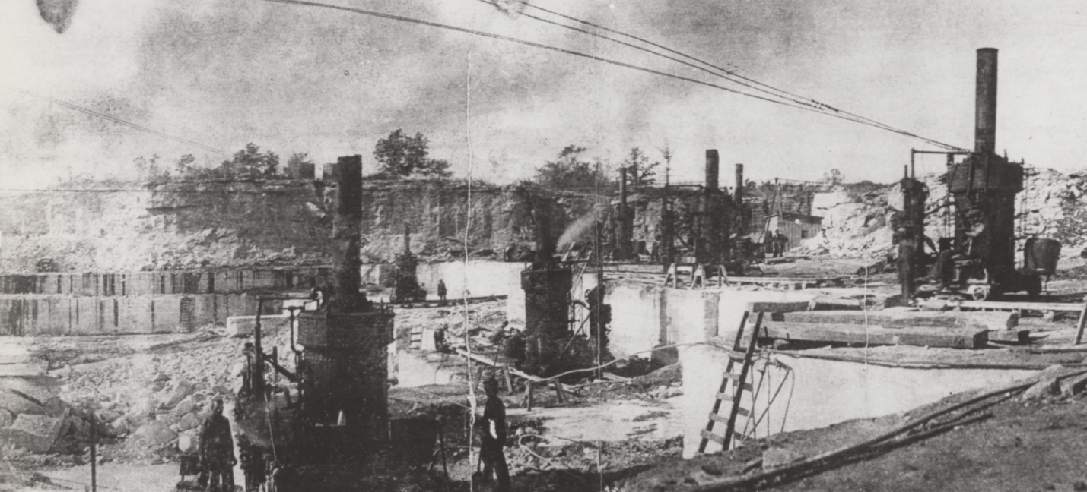
AB
C

Figure 9. Phenix quarry during late 1920s. All channeling machines that Phenix Marble Company owned were in action when this photograph was taken. The quarrymen called this going “full blast.” View is to northwest. High wall visible in background appears much the same today. The two channeler-cut ledges visible to the left are quarryman’s ledges “C” and “AB,” which are labeled on the photograph.

Starting in 1923, Phenix Marble Co. provided and paid for life insurance for its employees. This was unusual for the time. Anon. (1923, p. 218) reported,
“The Phenix Marble Company, Kansas City and Phenix, Mo., has issued to each of its employes [sic] a life insurance policy for $1,000, under a group plan. The premiums on the policies are paid by the company for this year, and will be continued thereafter if it is found that the plan meets all requirements for this class of protection.”
Phenix quarry was at the pinnacle of its operation in the latter part of the 1920s (Figure 9). Anon. (1927, p. 13 and 25) recounted these golden years of activity:
“Today the payroll of this company distributed in the City of Phenix alone, is over $11,000 a month and this enormous quarry ships each month forty-five to fifty cars of marble ‘in the rough’, [sic] to all parts of the United States and to foreign countries. It is known as ‘Napoleon Gray’ and has become nationally famous. In 1926, 500,000 cubic feet of rock was taken from this quarry….
“This quarry’s problem, if it might be called such, does not appear to be one of sales, but rather one of production, for during the last fifteen years new buildings have been added, additional modern equipment has been installed, and the plant is going at full capacity at all times to fill the orders...[and] the stone saw mill…operates twenty-four hours a day, every day of the year.
“Daily a Frisco switch engine from Ash Grove, seven miles away, is sent to Phenix to handle the switching of the heavy cars of rock. The two local trains a day from Ash Grove to Clinton and from Springfield to Clinton, bring in the supplies used by this quarry, such as grinding sand [St. Peter formation] from Pacific, Missouri, and sawing sand [chert chat] from Webb City, and take back car after car of marble consigned to points all over the United States….
“There are seven complete and modern shops to take care of the equipment, including a power house, blacksmith shop, stone saw mill, tile shed and compressor room, not to mention the ‘square roundhouse’….
“Stone has been removed from the quarry until great ledges have been formed. In the pit, the work extracting the huge blocks of marble goes on daily. The top ledge of rock is blasted off and used for road work, and when the marble itself is reached, a [coal-fueled steam] channelling [sic] machine is placed over it which runs on a double track. This machine is operated by an operator and a fireman, while the machine goes back and forth, drilling a channel through the solid rock at the rate of eight square feet per hour. Water follows the drill as it cuts through, to wash away any particles which might block its progress. This water is furnished from a well, 608 feet deep, and is pumped into a tank conveniently located near the quarry.
“When the 125-ton ledge is cut, usually in a size 22 feet long, 13 feet deep by four feet two inches wide, it is then lifted out and cut into blocks with air drills. These blocks are raised by derricks and placed on flat cars, and the ‘dinky’ locomotive hauls the flat cars to the stone saw mill, where they are cut and sized again….
“The town of Phenix, Missouri, is composed mostly of the marble company’s employees. The company owns three hundred acres of land on which may be found the quarry, homes and community house of its employes [sic]. And they are a happy lot. The company has recently erected for them a modern and up-to-date community hall at a cost of $18,000. Keil Hall, as it is known, was designed by a Kansas City architect contains its share of Napoleon gray marble work, with two immense fireplaces on either side. The hall proper seats 600 people, and the stage is ample for giving any kind of a performance. There are dressing rooms, reading rooms and a complete radio shop.
“The company rents homes to its employes [sic] at the rate of $5.00 and $6.00 a month. Most of these homes have little garden plots and pastures for stock. In the summer the company sponsors several picnics and bands come from neighboring towns to furnish music for dances and band concerts.
“Although Phenix is not prominently located on the main line, it is known the world over to dealers of marble, for it has a product which is in great demand, and the world has made path to Phenix, and taken from it a product which has aided in beautifying some of the most famous buildings in the United States.”
During the golden years, about 50 men were employed to operate the highly-mechanized quarry, whereas 100 to 125 men were employed in the “horse days” prior to 1923.

Decline Years: 1930 to 1986
Many factors brought on the decline of Phenix and of the marble industry in general. First and foremost was the economically disastrous Great Depression that started abruptly in 1929. Phenix Marble Company produced very little stone during the 1930s. Much of their business was completed using marble blocks from an extensive stockpile. Some unemployed workers had no choice but to leave Phenix. The town declined rapidly. It got to the point that the company sold the houses to the workers.
In May 1935, the railroad, then Frisco, abandoned a 35-mile stretch of track from Phenix north to Tracy Junction, which, as indicated by the Getty Thesaurus of Place Names, was near present-day Collins in southeastern St. Clair County. The six-mile stretch of railroad track from Phenix south to Ash Grove was pulled in 1942.
As of 1941, the quarry was approximately 700 feet long from north to south and 450 to 500 feet from east to west. The long face trended north 30 degrees west. An area measuring 250 by 350 feet in the northwest corner of the quarry was mined for crush rock. Phenix Marble Company suspended operations in 1943 (Hinchey, 1946, p. 22). Most of the steel on site was removed, probably recycled for the World War II effort.
In 1945, Vermont Marble Company purchased the Phenix properties and opened a new quarry at the spot previously mentioned by Buckley and Buehler (1904, p. 164) located just east of the south end of the old quarry. Hinchey (1946, p. 27) wrote,
“After their purchase of the properties at Phenix, the Vermont Marble Company opened a new quarry on the east side of the creek valley, approximately one-fourth mile east of the old Phenix Marble Company’s quarry. A preliminary drilling program, initiated in 1944, was followed by the installation of modern quarrying equipment and machinery. Channeling operations were started late in December 1945, and this new venture was well under way when the quarry was examined by the writer early in May 1946. Several car-loads of the stone had been shipped for processing.
“This new quarry (east) quarry is located…at a slightly lower surface elevation than the old west quarry…. The marble blocks are taken by truck to Walnut Grove, Mo., three miles north of the quarry, where they are loaded for shipment on the St. Louis-San Francisco Railway. The first two shipments have gone to Proctor, Vermont and San Francisco, California for processing.
“This new quarry is apparently located in the Keokuk formation of the Mississippian just below the Short Creek oolite which marks the base of the [overlying] Warsaw formation…[and which crops out] at the top of the section which was being cleared for quarrying in May 1946. The oolite is not well exposed here and is best seen in the excavation for the ‘dead-man’ anchor of the east guy-line cable for the derrick-mast.
“Stone is removed from the quarry by channeling and drilling. When examined a few months after channeling work had started, the new operation had extended two channel cuts into the face of the gently sloping valley wall. Surficial material had been removed to expose the limestone ledges for a distance of from 175 to 200 feet along the side of the valley in a generally northeast-southwest direction. Five electric channelers were in operation, and the channel-cuts had exposed a quarry face about 30 feet high.
“The ledges beneath the thin zone of surface weathering appear to be massive with stylolitic ‘sutures’ which are irregularly spaced in the beds. In blocks which have been removed from the quarry, the stylolite ‘seams’ or ‘sutures’ appear to be tight. The beds dip approximately 6° in a direction which is near to S. 35° E. This southeasterly dip is followed by the channeling machines, which are set to cut at that inclination.
“The quarry stone is crystalline, with grains [mostly echinoderm ossicles] of coarse to medium size; and it is stylolitic and fossiliferous. The local superintendent for the Vermont Marble Company reports that the polished marble prepared from the first shipments has an attractive and pleasing appearance.
“The operation is powered by electricity. Electric channeling-machines, an electric-powered compressor, and pneumatic drills are in use. The quarry is served with a 75-foot wooden-mast derrick. Reported plans for future operation include the development of lower beds, which have been prospected by the preliminary core-drilling, and extension of the face of the present workings along the valley wall to the northeast and southwest.”
It is rumored that excessive groundwater inflow prompted Vermont to abandon the new east quarry and to move its operations to the old west quarry that Phenix Marble had previously operated.
Carthage Marble Corporation purchased the property form Vermont on November 13, 1951. Carthage produced dimension stone from the quarry until 1977. Shortly after, Carthage Marble began selling all of its quarry properties. Phenix was sold to a private individual in 1986. Phenix was inactive for the next 30 years in regard to production of dimension stone.
Rebirth of Phenix: 2016
Conco Quarries, Inc., headquartered in Springfield, Missouri, resurrected the main west quarry for marble production in June 2016, under the historic Phenix Marble Co. business name (Figure 10). Blocks cut from the quarry are transported to Conco’s processing facility at Willard, where they are further cut and finished into a variety of quality marble products, including the stone that was used in a recent renovation of the Missouri State Capitol building in Jefferson City, Missouri.

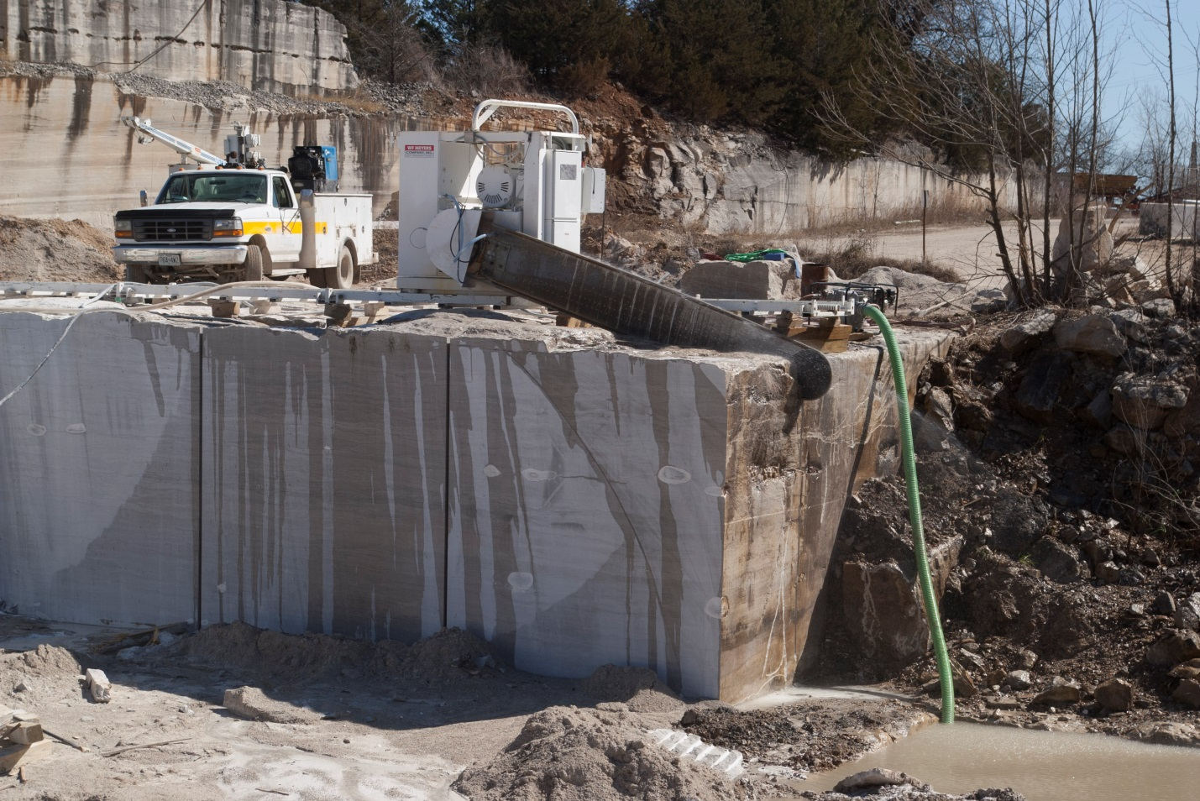
C
XAB
AB
C
AB

Figure 10. Present-day Phenix Marble Co. cutting out a block from quarrymen’s ledge “XAB” on March 2, 2017. Ledges “C” and “AB” are visible in background. “AB” ledge in background was cut with a long wire saw by Carthage Marble Co. during the 1960s. View is facing south. (D.L. Bridges photograph)

Strength and Purity of Phenix Stone
Phenix stone is a quality building material because of its high crush strength, freeze-thaw resistance, high density and low absorption characteristics. Hinchey (1946, p. 24–25) reported the following physical properties for Phenix limestone.
Crush strength dry across bedding………………………….11,773 psi
Crush strength dry parallel bedding………………………… 12,261 psi
Crush strength wet across bedding……………………..….. 11,967 psi
Crush strength wet parallel bedding………………………... 16,114 psi
Crush strength after 30 freeze-thaws across bedding…… 10,425 psi
Crush strength after 30 freeze-thaws parallel bedding……10,052 psi
Average bulk specific gravity……………………………...….. 2.643
Average bulk density……………………... 165.2 pounds per cubic foot
Average by weight absorption………………………….….0.452 percent
Average by volume absorption……………………………. 1.193 percent

Table 1 shows weight-percent chemical analyses for samples of Phenix limestone (Rueff, 1991, p. 33–34). The reported CaO contents are close to 56.03, which would be the weight-percent CaO analytical result for an absolutely pure calcite limestone.

Table 1. Weight-percent chemical analyses for samples of Phenix limestone.
Sample ID | CaO | MgO | SiO₂ | Al₂O₃ | Fe₂O₃ | MnO | Na₂O | K₂O | Loss On Ignition (CO₂) | Total | Specific Gravity
077-04-01 | 54.2 | 0.3 | 0.19 | 0.09 | 0.11 | 0.05 | 0.07 | 0.10 | 43.24 | 98.35 | 2.65
077-04-02 | 54.6 | 0.2 | 0.28 | - | 0.11 | 0.05 | 0.09 | 0.10 | 43.40 | 98.83 | 2.62
077-04-03 | 54.6 | 0.2 | 0.22 | 0.09 | 0.11 | 0.05 | 0.06 | 0.09 | 43.26 | 98.68 | 2.61
077-04-04 | 54.9 | 0.2 | 0.12 | - | 0.10 | 0.04 | 0.07 | 0.08 | 43.25 | 98.76 | 2.60
077-04-05 | 53.9 | 0.2 | 0.43 | 0.09 | 0.10 | 0.04 | 0.07 | 0.11 | 43.00 | 97.94 | 2.62

General Geology of Phenix Quarry
Phenix quarry is situated in the Mississippian Osagean Burlington-Keokuk Limestone area of outcrop (Figure 11). As implied by the geologic map, the rock section at Phenix is in the upper portion of the Burlington-Keokuk. Hinchey (1946, p. 27) noted that the Short Creek Member of the Keokuk Limestone crops out above the workings at Phenix. Therefore, it is reasonable to conclude that the ledges of commercial-quality stone at Phenix belong to the Keokuk Limestone, proper (Figure 12).

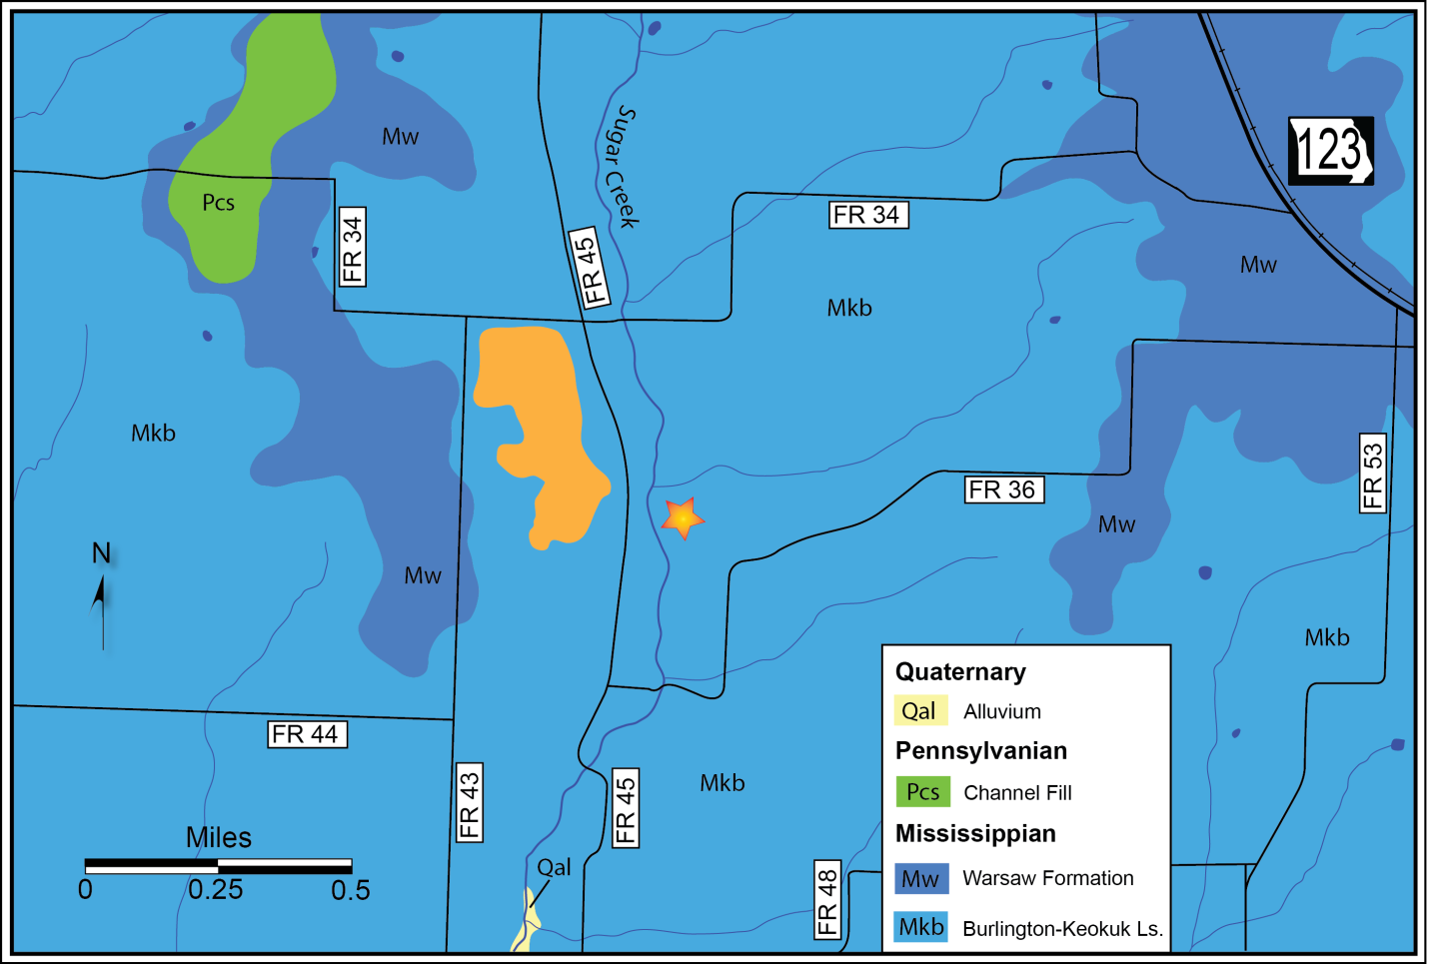
PHENIX
east quarry
west quarry

Figure 11. Geologic map of Phenix quarry and vicinity in northwestern Greene County, Missouri. Adapted from Searight (1960a, b) and Thomson (1982, 1983).
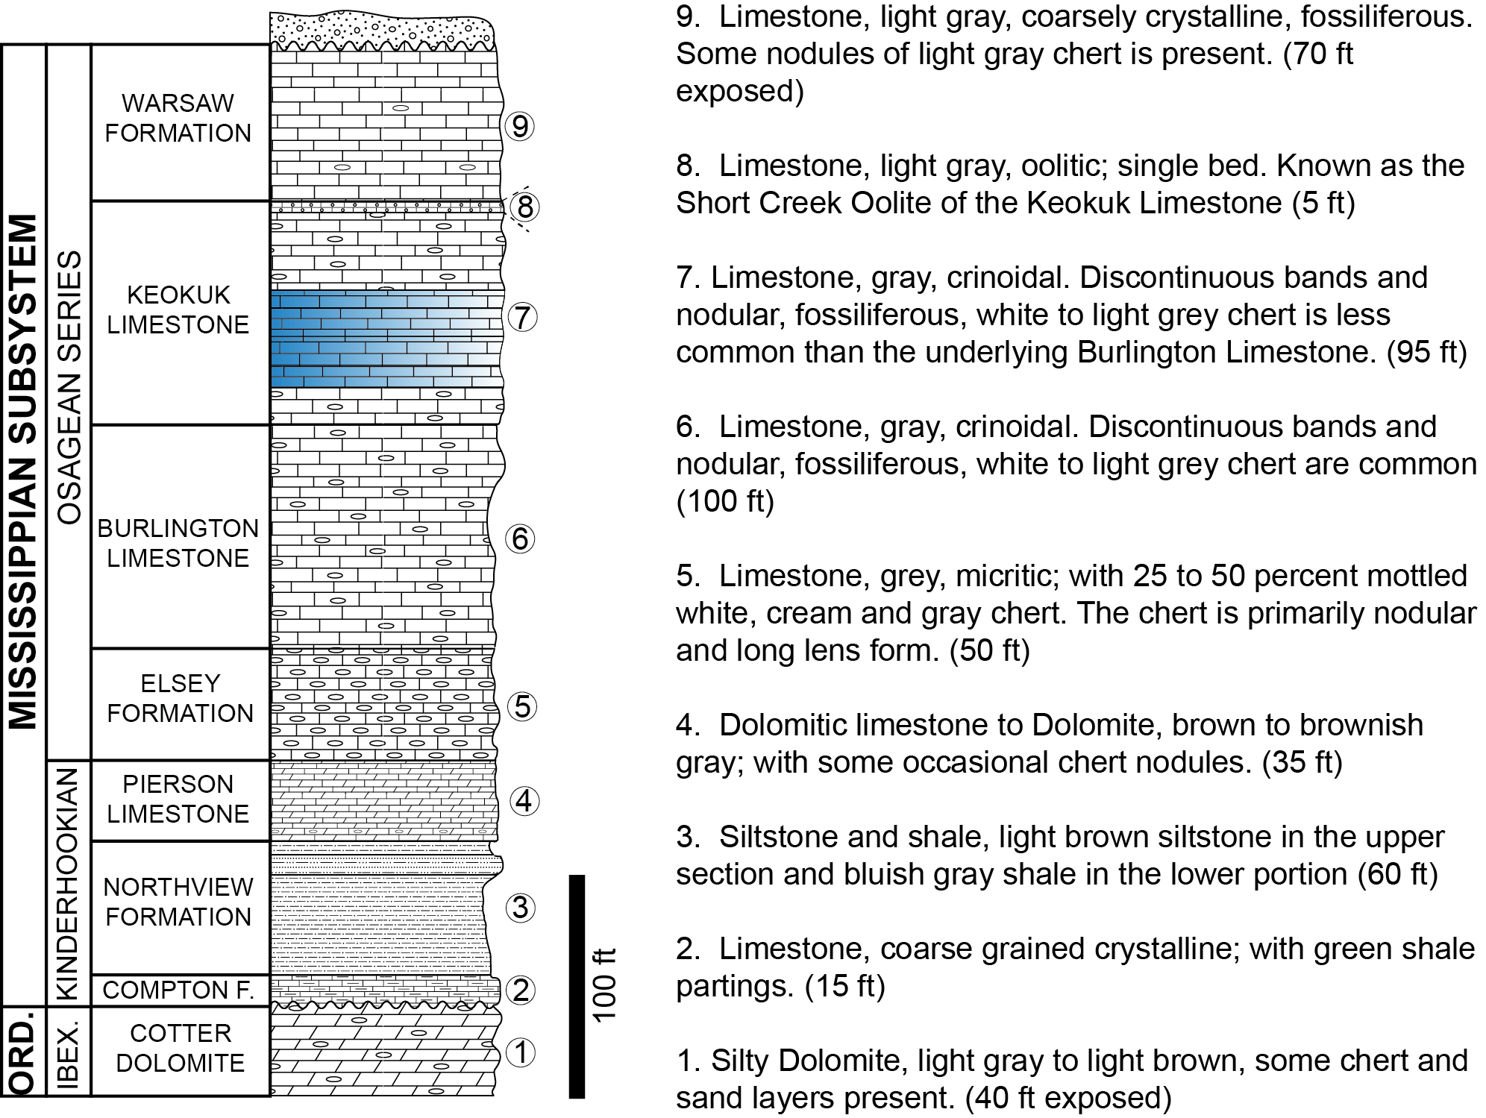

Figure 12. Generalized stratigraphic column for Phenix quarry and surrounding region in northwestern Greene County, Missouri. It is believed that the blue-shaded portion of this column represents approximately the interval of Burlington-Keokuk Limestone that has been and is currently being quarried at Phenix.

■ ■ ■

Third Leg of Road Log — Phenix to near Battlefield, Missouri
by
Staff of the Missouri Geological Survey

Numbers in left column are travel distances in statute miles. Red numbers are mile markers alongside federal routes. Features pointed out in this log can be viewed using Google Street View and associated aerial imagery.

0.0 Turn right out of Phenix quarry onto North County Road 45 and travel south a short distance.
0.3 Turn left onto West County Road 36 and wind your way back east to Missouri Route 123.
2.5 Turn right onto Missouri Route 123 and return to U.S. Route 160.
7.8 Turn left onto U.S. Route 160 and head east back to Interstate 44 interchange.
12.5 Passing Conco Quarries, Inc., property on the north (left) side of road.
14.0 Driving through a large sinkhole plain in which there are approximately 150 sinkholes in a ten square mile area.
14.4 Passing through two large shallow sinkholes.
16.3 Turn right onto Interstate 44 and head west.
16.6 75.2. First mile marker seen along right side of interstate highway.
74.0–73.8. Drive under overpass.
19.3 72.5. Drive under overpass of State Route 266 or Chestnut Expressway.
72.5–72.4. Burlington-Keokuk Limestone pinnacles and intervening, vegetated red clay cutters are exposed on both sides of highway.
21.4 70.4. Exit right at Exit 70 and drive up exit ramp.
21.6 Turn left and head south on State Route MM.
23.3 Cross over Missouri Route 360. Stay on MM.
25.4 Cross railroad crossing.
25.5 Traffic signal at intersection with U.S. Route 60, where Route MM changes to Route M. Go straight through intersection on Route M.
26.2 Turn right onto Missouri Route ZZ and proceed south. Note cherty, red clay residuum on left side of road. Then note Burlington-Keokuk Limestone and red residuum in places alongside the road.
27.7 Turn left onto West Farm Road 182 and head east a short distance.
27.8 Turn right into Wilson’s Creek National Battlefield and drive back to the visitor’s center.

■ ■ ■

STOP 3 — Wilson’s Creek National Battlefield
by
Douglas R. Gouzie
Missouri State University, Springfield, Missouri

Introduction
Wilson’s Creek National Battlefield (WCNB) is the site of the first Civil War battle west of the Mississippi River. It is also where the first Union army general to be killed in the Civil War lost his life. The battlefield is located on the Springfield Plateau portion of the Ozark Plateau physiographic province, a few miles southwest of the current Springfield city limit. Rocks exposed in the park are primarily the Burlington-Keokuk Limestone, with some sporadic exposures of underlying Elsey and Reeds Spring Formations along creek banks and near the southern edge of the property.
Our tour will make two to four brief stops, time and weather conditions permitting. These stops are discussed below in the Features and Issues section. Historical information in this section has come from the Wilson’s Creek National Battlefield and Pea Ridge Battlefield (Arkansas) websites of the National Park Service and from personal communication with Mr. Bruce Heise of the Geologic Resources Division of the National Park Service.

History
The history of Wilson’s Creek National Battlefield is tied deeply to America’s Civil War and the somewhat unique role Missouri played in the war as a border state. Early in the war, the Missouri legislature voted to remain in the Union, although Governor Claiborne Jackson and the Missouri State Guard (a militia authorized by the Missouri legislature) appeared to be sympathetic to the Confederacy. In addition, the Union army saw the importance of the Mississippi River and created a post in St. Louis. Union forces used this post and the Missouri River to push the Missouri State Guard and Governor Jackson out of the State Capitol at Jefferson City and eventually pushed the Guard out of Missouri completely. Wilson’s Creek National Battlefield marks one place where Union forces had a major confrontation with the Missouri State Guard. As Union forces advanced southward to Springfield, the Missouri State Guard, under the command of former Missouri Governor Major General Sterling Price, had camped along the banks of Wilson’s Creek at what is now Wilson’s Creek National Battlefield.
By summer 1861, Union Brigadier General Nathaniel Lyon brought his garrison from the post at St. Louis to the Springfield area. In August 1861, the Union army found the Missouri State Guard camped along Wilson’s Creek a few miles outside of Springfield, and the battle ensued. Essentially, the Union army was occupying the high ground at the northern portion of the current park and the Missouri State Guard was camped along the creek in a field in the southern portion of the current park. While General Lyon prepared his forces for battle, Union Colonel Franz Sigel of the 3rd Missouri Infantry, flanked the Missouri State Guard camp, positioning his troops on a bluff overlooking Wilson’s Creek just outside the southeastern boundary of the current park. This created a situation where one set of Union forces could push General Price’s troops into another brigade of Union forces. In fact, as we tour the Battlefield, we will see that the natural topography of the karsted limestone played a role in this battle. The Union forces under Sigel’s command effectively pushed the Missouri Guard troops up a narrowing draw or karst blind valley, which funneled them directly into a battery of Union cannons. However, the sheer number of Missouri Guard troops—compared to the smaller brigades of Union soldiers this far away from the post in St. Louis—meant that the Union army, having lost General Lyon during this particularly bloody battle, was forced to retreat to Springfield.
We hope to stop at a few locations to observe park locales relevant to the battle and geologic points of interest.

Features and Issues
Stop 3A — Ray House. Following our break at the Visitor’s Center, our group will plan to stop at the Ray House, one of the historic homesteads that was a farm before this area became a Civil War battlefield. National Park Service staff will guide our tour of the house and explain its history. As we approach the house by bus from the east, you might notice a small outbuilding called Ray Springhouse that houses a small karst spring at the base of the hill. It provided water for the Ray family and served as a place for cold storage. After the Ray House, we will pass by an old quarry that probably dates to about the 1880s.

Stop 3B — Geology Note. About 0.5 miles past the Ray House, we will likely make a look-out-the-windows stop at a wide place in the road. To the east is a road cut of Burlington-Keokuk Limestone, approximately 20 feet high. This road cut displays the irregular chert nodules, fossiliferous limestone, and even some weathered red clay residuum filling areas of likely groundwater flow or karst development. Typically, a small groundwater seep emerges from a fracture near the base of this road cut, exemplifying much of the shallow groundwater flow in the Springfield area—flow which may be perched on muddier or siltier horizons in the Burlington-Keokuk or which may be true outflow from the water table, as is the situation for the perennial flow of Wilson’s Creek.

Stop 3C — Price’s Encampment. After rounding the southern portion of the park road and crossing Wilson’s Creek, we will pass by the field where Price’s Missouri State Guard was camped when the battle began.
It is worth taking note of Wilson’s Creek as we pass over the stream because Wilson’s Creek is a major drainage for roughly the western half of Springfield, whereas the eastern portion of Springfield drains toward Sequiota Park and the James River. Draining roughly 50 square miles, Wilson’s Creek also is notable for the input of Rader Spring, the second largest spring in Greene County, about 2 miles upstream of the Battlefield. Both Wilson’s Creek and Rader Spring appear to receive surface water runoff and shallow groundwater funneled to the southwestern portion of Springfield along the top of the shale-dominant Northview Formation, which is a leaky confining unit that hydrologically separates underlying Ordovician dolomites of the Ozark Aquifer from overlying Mississippian limestones of the Springfield Plateau Aquifer. Coupled with the regional northwest-southeast trending Battlefield Fault Zone, it is clear that hydrogeologic conditions favored the area around Wilson’s Creek National Battlefield as an area of abundant water resources.

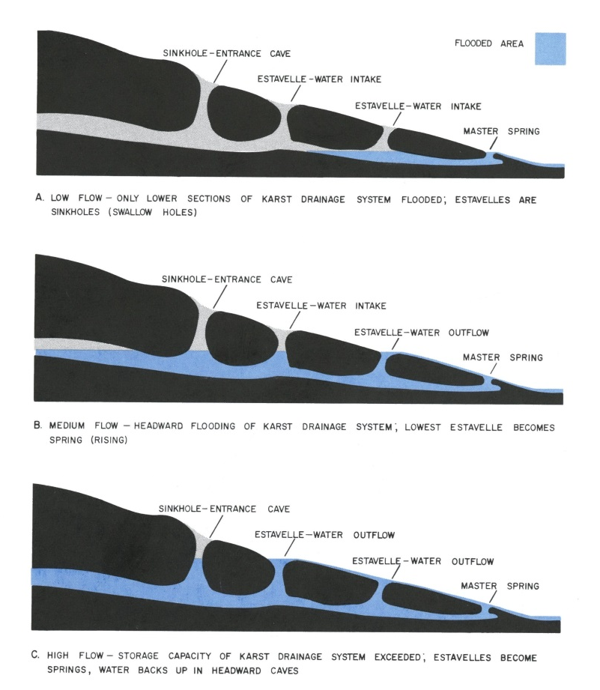

Figure 13. Conceptual model that invokes estavelles and fluctuating water volume to explain observed behavior of surface water and shallow groundwater between Wilson’s Creek and Rader Spring. Reproduced from Vineyard and Feder (1982, p. 179).
Historic dye traces reported by the late Jerry Vineyard (former Assistant State Geologist) found interesting results when at least one trace went into a sinkhole on the east bank of Wilson’s Creek and surfaced at Rader Spring on the west bank of the creek roughly one-fourth of a mile downstream from the injection point without any dye being detected in the creek between those two points (Vineyard and Feder (1982). This provided strong evidence that certain beds or horizons in the Burlington-Keokuk Limestone may be sufficiently muddy, silty, or so coarsely crystalline as to serve as confining layers that are capable of directing lateral flow of water within the Burlington-Keokuk well above the top of the Northview. In fact, Vineyard and Feder (1982) reported the results of multiple dye traces by various investigators and concluded that Wilson’s Creek has a number of estavelles (i.e., openings that function both as sinkholes and springs, depending on underground water levels) in the reach approaching Rader Spring. This led them to hypothesize a flow system where sinks and discharge points are controlled by water volume in the system (see Figure 13). This finding has made for many interesting discussions amongst environmental and water resources professionals in the region.
We will stop at a parking area designated “Sigel’s Second Position” as his forces advanced during the battle. From the parking area, we will walk west about 700 feet up the Old Wire Road, which has its own history. The Wire Road is generally considered to be the trail that linked Springfield and other parts of early Missouri with Fort Smith, Arkansas, and points west. After some usage of the trail had built its reputation, the Butterfield Stagecoach followed the road on its routes between Springfield and Fort Smith. Additionally, this same trail was used to push Cherokee and other tribes westward to lands in Oklahoma and consequently became known as the Trail of Tears. Knowing the history of the Wire Road also aids in understanding why various army forces might have chosen to travel through this area and camp in the vicinity.
As we walk uphill from the parking area, one may notice a small fenced area near the brow of the hill. This area marks a relatively recent (early 2011) sinkhole which opened up and displays a common feature of the southwestern Missouri karst landscape. All across this region, the relatively flat-lying carbonate rock units have been widened by dissolution along joints that open up over time to eventually allow enough soil to pass through and drain out, leaving a void that either subsides gradually or collapses somewhat suddenly. Studies at Missouri State University have suggested that about 90–95% of these sinkholes develop as broad, gently-sloped dolines, while the remaining 5–10% could open up as collapse features. Many farmers report collapse features from grapefruit to medicine ball size that, with the aid of a flashlight, appear to be open shafts down to 10–20 feet depth through the soil. Simply filling one of these holes with rocks culled from the fields typically stiffens the soil enough to prevent further widening of the hole. For this particular hole, the Park Service has opted to simply fence off the area while contemplating the best way to address the feature.
For our purpose, we will simply note that whatever vertical or near-vertical jointing existed that led to opening of this hole, the feature itself is simply collecting water runoff from the hill and funneling it down to groundwater baseflow which supplies Wilson’s Creek. Sinks like this seem to form most commonly either fairly close to the existing surface springs and streams or fairly high up on hillsides where the greater elevation difference between ground surface and base level provides more of an impetus to drive the water downward and carry sediment out. An extreme example of this greater impetus occurred in 2006 in the nearby town of Nixa, Missouri, where a sinkhole approaching 55 feet in diameter and nearly 100 feet deep claimed a house (Figure 14).

Stop 3D — Bloody Hill. At this stop, we will see the area of fiercest fighting at Wilson’s Creek battlefield. The brow of this hill is where General Lyon’s Union cannons were placed, and the park trail here winds from the parking area past the cannon positions and then winds along the edge of the dry karst valley where Price’s Missouri State Guard soldiers were funneled toward the cannons. A bit further along the park trail, just on the other side of the natural ravine, an old sinkhole that existed in Civil War times can be found along with a marker explaining that both sides took heavy casualties during the battle, and that Confederate officers directed their surviving troops to place the bodies of dead soldiers into the sinkhole as a mass grave before the August heat had a chance to take its gruesome toll on the corpses.

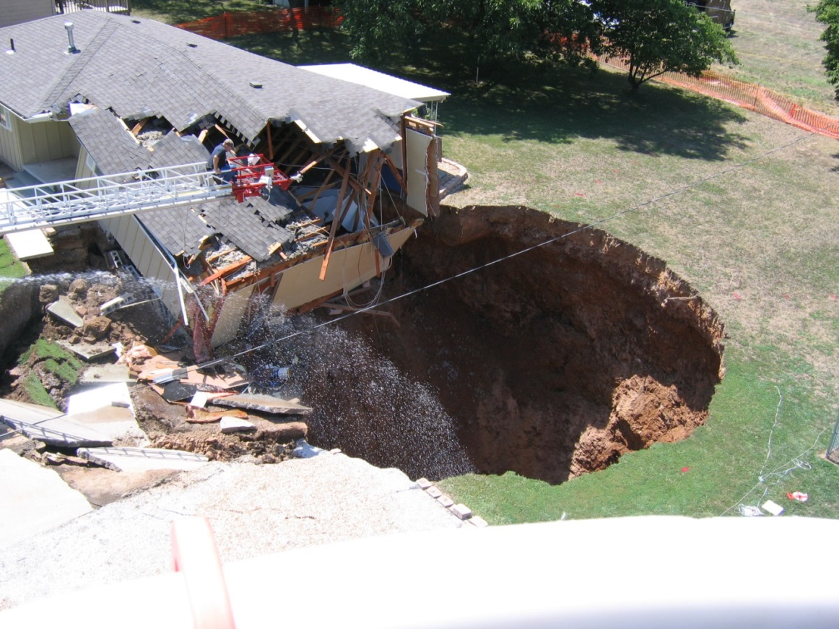

Figure 14. House claimed by sinkhole collapse at Nixa, Missouri, in 2006. (D.R. Gouzie photograph)

■ ■ ■

Fourth Leg of Road Log — Return to Branson, Missouri
by
Staff of the Missouri Geological Survey

Numbers in left column are travel distances in statute miles. Red numbers are mile markers alongside federal routes. Features pointed out in this log can be viewed using Google Street View and associated aerial imagery.

0.0 Turn left out of Wilson’s Creek National Battlefield onto West Farm Road 182 and travel a short distance west.
0.1 Turn right onto Missouri Route ZZ and head north back to Missouri Route M.
1.6 Turn left onto Missouri Route M and head west back to U.S. Route 60 intersection.
2.3 At traffic signal, turn right onto U.S. Route 60 and head northeast.
4.2 Exit right onto U.S. Route 60 and head east.
Burlington-Keokuk Limestone is exposed in road cuts along the way.
14.1 Exit right onto U.S. Route 65 and head south back to Branson. The 44.8 mile marker will probably be the first one you will notice.
47.3 13.6–13.4. Exit right at Branson Landing Boulevard exit. Then, turn left onto Branson Landing Boulevard.
48.6 Turn right onto East Main Street and cross railroad track.
48.7 Turn left onto South Sycamore Street. Turn left into Branson Convention Center.
■ ■ ■
Mid-Meeting Field Trip, June 13, 2017

■ ■ ■
First Leg of Road Log — Branson to Silver Dollar City, Missouri
STOP 1 — Marvel Cave
□ □ □
Second Leg of Road Log — Silver Dollar City to Top of the Rock, Missouri
STOP 2 — Top of the Rock
□ □ □
Third Leg of Road Log — Return to Branson, Missouri
■ ■ ■

Figure 15. Map for Mid-Meeting Drive Route Legs and Stops

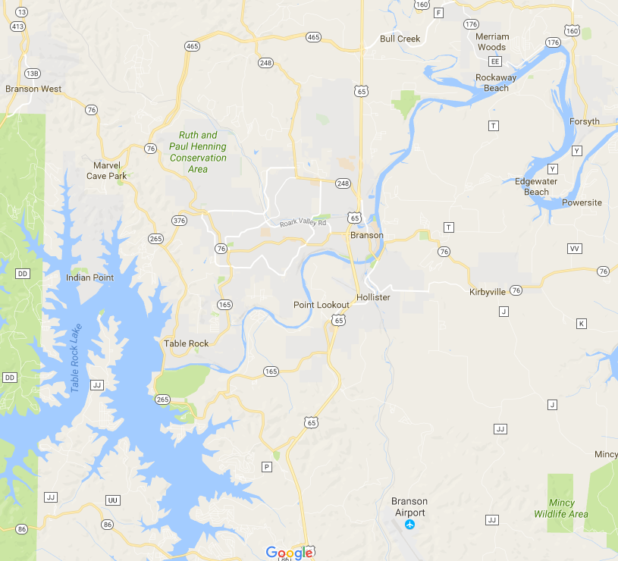
STOP 1 Marvel Cave
Leg 1
STOP 2
Top of the Rock
START—END
41 mi. Total
Leg 2
Leg 3
N

First Leg of Road Log — Branson to Silver Dollar City, Missouri
by
Staff of the Missouri Geological Survey

Numbers in left column are travel distances in statute miles. Red numbers are mile markers alongside federal routes. Features pointed out in this log can be viewed using Google Street View and associated aerial imagery.

Turn right out of Hilton Branson Convention Center onto South Sycamore Street and head north for very short distance to intersection with East Main Street.
0.0 Turn right and head east on East Main Street for very short distance.
0.05 Stop at railroad crossing. Turn left and head north on Branson Landing Boulevard. Get in right lane and stay there. Go straight through traffic light at Commercial Street intersection. Cross bridge over White River. Enter traffic circle (aka roundabout) and proceed uphill on Branson Landing Boulevard. Stay in right lane.
1.0 Turn right onto U.S. Route 65 and head north towards Springfield.
1.3 12.6. First mile marker seen along east (right) side of highway. For next 10 miles, essentially flat- lying, variably cherty and silty, Ordovician Ibexian Cotter Dolomite is exposed in road cuts. Cotter thickness ranges from 100 to 300 feet in this southwestern portion of Missouri (Thompson, 1991, p. 50). See generalized state geologic map in Appendix.
4.6 15.8–16.0. Exit right off of U.S. 65.
4.9 Turn left onto Missouri Route 465 (aka Mountain Highroad) and head west. Flat-lying Cotter Dolomite is exposed in rock cuts in the interchange.
5.1 Proceed straight through intersection with Adair Road.
5.2 Davis (2003, p. 69) stated, “On Route 465 approximately 330 yards west of the intersection with Route 65…a cave was found while a rock cut was being excavated [in the late 1990s]. Named the Highroad Horror Cave, this cave dropped 50 feet under the road from a six-foot by two-foot entrance on the ditch line of the route. A small stream issues from an area just under the cavern entrance with approximate discharge of 5 gallons per minute. This stream flows down the sides of the pit becoming a small waterfall about 8 feet below the entrance to the pit. As the pit does not seem to be endangering the highway, the current drainage path was preserved, and the project continued….”
5.4 Ordovician Ibexian Cotter Dolomite is exposed in large, three-tiered road cut. Cotter is exposed along the way in numerous other road cuts.
12.0 Three-tiered road cut on east (left) side of road. Bottom tier consists of Cotter Dolomite that is capped by thin Mississippian Kinderhookian Bachelor Formation that host fish remains and the ichnogenus Zoophycos (Plymate et al., 2004, p. 48). Middle tier, from bottom to top, comprises Kinderhookian Compton Limestone, greenish Kinderhookian Northview Formation and Osagean Pierson Limestone. The top tier is Osagean Reeds Spring-Elsey Formations.
12.5 Exit right into U-turn at interchange with Missouri Route 76.
12.8 Turn left onto Missouri Route 76 and travel west.
13.1 Go straight through traffic signal at intersection with Missouri Route 276.
13.7 Turn left onto Indian Point Road at traffic signal and head south. Marvel Cave Fault straight ahead in valley.
14.0 Veer right onto Silver Dollar City Parkway. Proceed south and use signs to navigate to bus drop- off area.

■ ■ ■

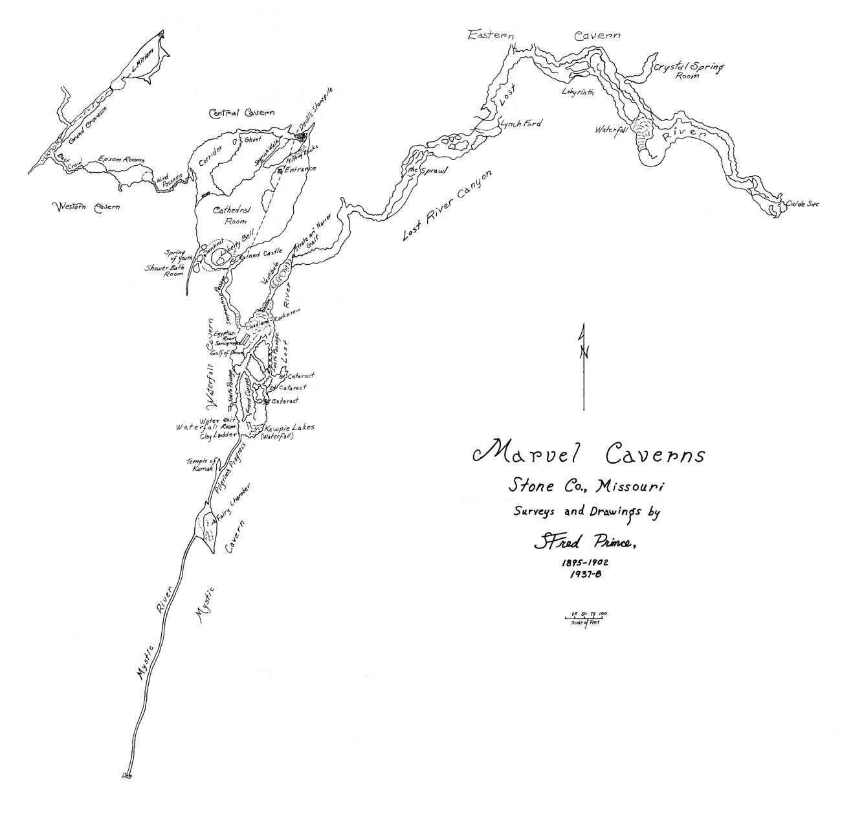

Figure 16. Map of Marvel Cave, Stone County, Missouri

STOP 1 — Marvel Cave
by
Larry D. Pierce and Jerry L Prewett
Missouri Geological Survey

Introduction
Over half of Missouri is underlain by carbonate bedrock units prone to solution weathering and karst development. As a result, there are approximately 6,900 caves, 14,600 sinkholes and 4,500 springs known to exist in the state, mostly in the Ozarks. Karst areas of the state are prone to both natural and man-made hazards including catastrophic collapse, flooding, and differential settling. These hazards often allow negative conditions to develop that increase groundwater contamination, construction difficulties and public safety issues. Karst processes that create those hazards are the same processes that make some of the most beautiful and impressive subterranean environments. Some of the most impressive are Missouri’s 17 commercial show caves. Marvel Cave is a well-known and highly visited show cave with a history that is as interesting as the geology. As with much of the Ozarks the true history is entangled with folklore making the truth a bit murky. Harold Bell Wright was a frequent visitor and through his vivid imagination the cave was woven into the fabric of Shepherd of the Hills. Legends of prehistoric beasts, Spanish gold, and dark deeds still persist, though they have little basis in fact.

Cave History
The entrance to Marvel Cave is through the throat of a large sinkhole that was known to Native Americans. Vertical distance from entrance to cave floor is over 200 feet. Native Americans apparently feared the deep entrance, which may be why there is no evidence of their inhabitance of the cave. They are, however, credited with giving the cave the original name of Devil’s Den. In 1541, Spanish explorers are reported to have entered the cave in their pursuit of riches and possibly the fountain of youth. The first confirmed entry of a human into the cave was in 1869, after the Civil War. A group of miners led by Henry T. Blow lowered themselves one by one into the cave by ropes in search of lead ore. They are said to have spent several hours studying the walls of the cave for signs of mineral deposits. The miners did not find any ore deposits, but they were convinced there was marble in the cave. Their report sparked the interest of area locals who decided to rename the cave Marble Cave (Anon., 2017).
In 1881, the Marble Cave Mining Co. was founded by a group of investors from Lamar, Missouri, to mine lead, zinc or marble from the cave. Just as the earlier miners had discovered, no lead, zinc or marble was found. The mining company did find deposits of bat guano that was mined for several years from the dry passages west of the Cathedral Room and shipped to Berryville, Arkansas. The surface above was divided into lots and a town named Marmaris sprang up on the site now occupied by Silver Dollar City. At one time, Marmaris had a school house, general store, foundry, woodworking shop, and a pottery in addition to the guano mining operation. The potter obtained clay from the filled sink now circled by the main line of Marvel Cave Railroad. Local historians say the town was burned by Bald Knobbers in 1893 (Vineyard and Fellows, 1967).
In 1890, William Henry Lynch, a Canadian writer and miner, was so fascinated by rumors of prehistoric animal bones in Marble Cave that he bought the property sight unseen. In time he discovered that piles of bones did not exist. Nonetheless, his experience with the cave caused a love and long-term interest. He soon moved with his two daughters to Missouri and began working on the cave. In 1894, Lynch and his daughters Miriam and Genevieve opened Marble Cave to visitors, exhibiting the enormous chambers first by candlelight, then by the flickering glow of lanterns. Visitors came by railroad to nearby Garber, where they were met by wagons for the three-mile trip to the cave. The scientific community of the day learned of the cave through an expedition sponsored by the Missouri Bureau of Geology and Mines (now Missouri Geological Survey) and the World's Fair Commission that was reported in Scientific American in 1893. It was not until after Mr. Lynch's death in 1927, that the cave's name was changed from Marble to Marvel Cave. No marble was ever mined from Marble Cave, only bat guano (Vineyard and Fellows, 1967).

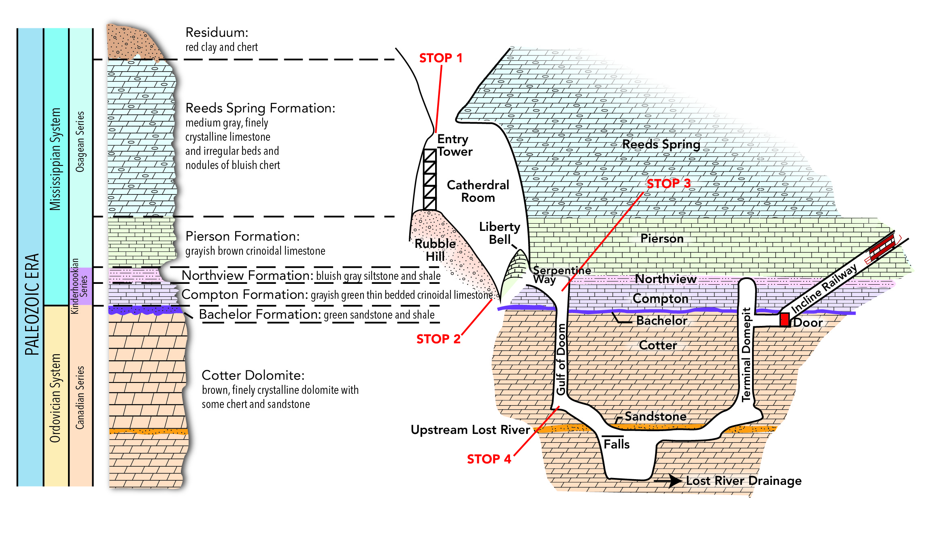

Figure 17. Cross sectional view of Marvel Cave alongside geologic column for regional stratigraphy. Entry tower circa 60 feet tall.

Cave Passage Travel Log
J Harlen Bretz (1956) described Marvel Cave in vivid detail. Being a proponent of peneplanation theory, he argued persuasively that the cave originated through solution of carbonate rock in the phreatic zone, far beneath the water table and under the Springfield peneplain. According to Bretz, clay filling followed initial solution, and the fill was removed by free surface streams following decline of the local water table with regional uplift and rejuvenation of the surface streams. Our intent is neither to strengthen nor refute Bretz's arguments.
The following description of Marvel Cave was taken from Vineyard and Fellows (1967) with minor modification. The entrance to Marvel Cave lies near the summit of Roark Mountain on a ridge between Indian Creek and Jake’s Creek. The cave entrance is approximately three miles north of the now flooded White River (now Table Rock Lake) and approximately 600 feet above the river’s original elevation. Mississippian Reeds Spring strata cap the ridge and lie exposed in the steep rock walls of the entrance. The Reeds Spring Formation is a cherty limestone and may be closely examined from the stairway. The cherty ground of Indian Ridge gives no hint of the cave beneath, except for the large, water filled sink circled by the "main line" of Marvel Cave Railroad. Descent through the double skylights of the entrance sinkhole brings the visitor to a vantage point overlooking the Cathedral Room. (STOP 1) The base of the steel-and-concrete entry tower appears to be on a seemingly gentle mound of debris, but is actually a high rubble hill. The huge, stalagmitic Liberty Bell can be seen extending upward towards an open joint in the ceiling; thin-bedded Reeds Spring strata can be easily distinguished in the joint bounded southwestern walls. Closer observation reveals the Pierson, Northview, and Compton formations, which are more easily seen from our next stop at the Liberty Bell far below.
The massive Liberty Bell is the largest secondary mineral formation (speleothem) in Marvel Cave. It was created by meteoric water that descended through joints and fissures in overlying bedrock, entered the Cathedral Room, and then deposited the calcium carbonate that it had acquired during its journey through the overlying bedrock. The complex stalagmite shows several stages of growth, including at least two periods of subsidence, when increasing weight of the speleothem caused its rubble base to shift.
(Stop 2) Looking beyond the Liberty Bell to the southeastern walls of the Cathedral Room, one can clearly see the contact of the Pierson Limestone with the cherty beds of the Reeds Spring Formation. The shaly Northview Formation forms a reentrant between the underlying Compton Limestone and the overlying Pierson Limestone. The trail leads behind the Liberty Bell into the Serpentine Way, en route to the Gulf of Doom. Note the massive flowstone (cave onyx) exposed in the ceiling and wall rock behind the Bell. Here the trail passes through an opening left when the massive Bell broke away from the bedrock wall to which it had been attached. Dripping water from the parent joints has recently become aggressive and is actively carving grooves in the vulnerable back of the Liberty Bell.
Serpentine Way is a narrow, sinuous passage stratigraphically restricted to the Compton Limestone and Northview Formation. The ceiling is formed by basal Pierson Limestone. The floor has a gradual slope toward the end of the Way where it terminates in the Egyptian Room (sometimes called the Shoe Room), which contains a large fallen block of Compton Limestone, called the Sarcophagi, and the Gulf of Doom. (STOP 3) The ceiling of the Egyptian room is a remarkably smooth Pierson Limestone bedding plane. The Northview Formation is easily distinguished below the ceiling, and the smoothly-sculptured, medium-bedded Compton Limestone forms the lower walls. By looking beneath the ledge near the Gulf of Doom, one can see the thin Bachelor Formation, and trace it around the fluted walls of the Gulf of Doom.
Vertical shafts carved by dripping water are common features of caves. They form beneath resistant strata, such as beds of chert, often at the intersection of joints where vadose water is plentiful. The shafts propagate downward until other resistant beds are encountered, or to the water table. Thin, resistant layers sometimes cause constrictions, but are unable to halt development of the shafts. Walls of vertical shafts (also called domes or dome pits) are commonly fluted. Water cascading down one of the shaft eventually develops long, narrow chambers with grooved walls. The Gulf of Doom is an impressive example of a 130 feet high vertical shaft. On its walls are pockets and joints filled with red clay. This likely supports Bretz' case for an episode of clay filling of the void.
The trail to the green-lighted pool at the base of the Gulf of Doom leads downward through a complex network of descending channels called Cloudland. The "clouds" are differentially-dissolved remnants of Cotter Dolomite (contact of the Cotter Dolomite and Bachelor Formation is at floor level in the Egyptian Room). The Cotter Dolomite is heavily pitted at this level, but becomes more smoothly sculptured at lower levels. Examine Cloudland closely; note the red sediment, first in ceiling cavities and joints, then in laminated deposits along the trail.
Zig-zag stairways lead down through a maze of descending tunnels. Fallen ceiling blocks are wedged in narrow passages in several places. Note: the descending ceiling channels were likely cut when the passages were nearly filled causing the small streams to press against the ceiling and erode small, upside-down channels. The streams which flowed through this section possibly came from the Serpentine Way, before forming by solution-collapse of the Cathedral Room, and prior to development of the Gulf of Doom.
(STOP 4) From the base of the Gulf of Doom, the smooth Pierson Limestone ceiling of the Egyptian Room contrasts with the grooved and fluted walls of the vertical shaft. The undercut flange at the base of the shaft is a characteristic feature of dome pits.
The underground course of Lost River is first encountered in the Waterfall Room, which marks the lowest point in the cave shown to visitors. Dripstone formations enhance the beauty of the falls. A trip along the trail over the falls reveals a series of rimstone dams clustered on the brink. Upstream from the waterfall is a man-made dam designed to control rainwater runoff that flooded the Waterfall Room after heavy rains, forcing cancelation of tours. The dam allows floodwaters to be temporarily stored and released gradually.
Water tracing with fluorescein dye was used to prove the Lost River is connected via subsurface to Neely's Spring where it resurges two miles away in Indian Creek valley. Neely’s Spring is now submerged beneath the waters of Table Rock Lake. Lost River may be followed for about 2,000 feet upstream, but its downstream course remains unknown, whereas the upstream channel terminates in breakdown. Control of cave passages by stratigraphy is nowhere more clearly shown than in this small passage, where its ceiling of sandstone is the formation of least erosion. The narrow, sinuous passage ends near Blondie's Throne, where an impressive display of dripstone forms high on the walls of a small chamber.
From the Throne Room the trail leads upward via zig-zag stairway constructed generally adjacent to another high vertical shaft. Near the top of the shaft a false floor has been built to serve as a landing for the stairway, a rest area, and a vantage point from which to observe the dome pit. The term "dome pit" is particularly apt here, where one looks up to see a dome and when looking down sees a pit. Again, the origin of the shaft is evident from study of the wall features. Some waterfall recession has occurred, giving the shaft an oblong plan. A long-term record of water erosion is caused by cascading spray that has cut inclined grooves on the walls. Several incipient flanges show former temporary positions of the base of the shaft.
In 1958 cave management sunk an inclined shaft from the surface to intersect the cave at a level near the top of the terminal dome. A cable railway was built from the shaft to Hospitality House so the visitors would not have to make the long climb up the Gulf of Doom and out of the Cathedral Room. Air flow and humidity problems caused by the artificial entrance are avoided by a door at the rail terminal. Stratigraphy on the climb out of the cave is the reverse of that going in. Before leaving the cave, note the Bachelor Formation just one foot above the door. To board the inclined railway, one must walk up a flight of steps to a seat of your choice.
If you choose the last (highest) seat at the top of the stairs, note the succession of rock units, starting with the Bachelor Formation, just above door level, through the Compton Limestone, Northview Formation, and finally the Northview Formation-Pierson Limestone contact at the top of the stairs. On the train ride out, only the Pierson Limestone is exposed; the Reeds Spring Formation and Burlington Limestone do not crop out in the tunnel.

□ □ □

Memorial
Jerry D. Vineyard (1935–2017)

The writers of this section of the guidebook would like to thank Mr. Jerry D. Vineyard for this description of Marvel Cave originally printed in the Missouri Geological Survey Report of Investigations No. 37. Mr. Vineyard was a geologist at the Missouri Geological Survey and Assistant State Geologist during the latter part of his career. He loved speleology and was an icon in the Missouri Speleology Society. Jerry passed away in March of 2017. His contributions to the knowledge of Missouri’s geology and karst environments were numerous and he will be sorely missed.

■ ■ ■

Second Leg of Road Log — Silver Dollar City to Top of the Rock, Missouri
by
Staff of the Missouri Geological Survey

Numbers in left column are travel distances in statute miles. Red numbers are mile markers alongside federal routes. Features pointed out in this log can be viewed using Google Street View and associated aerial imagery.

0.0 Exit Silver Dollar City onto Indian Point Road and travel north a short distance back to Missouri State Route 76.
0.3 Turn right onto Missouri Route 76 and proceed east.
0.9 Turn right onto Missouri Route 265 and proceed south.
6.4 Turn right to stay on Missouri Route 265.
7.2 Cross Table Rock Dam.
10.5 Turn right to stay on Missouri Route 265.
13.7 Turn right onto U.S. Route 65 and proceed south.
14.0 5.4–5.0. Reeds Spring-Elsey Formations exposed on west (right) side of road. Note pinnacles and cutters. Note the layers of chert. Note the cutters that have been skillfully filled in with slabs and blocks of local stone.
16.4 2.8. Turn right onto Missouri Route 86 and proceed west a short distance.
16.6 Negotiate round-a-bout and enter Bass Pro Shops property from north (right) side of round-a-bout. Travel north 3 miles to Bass Pro Shops’ Top of the Rock.
■ ■ ■
STOP 2 —Sinkhole Excavation at Top of the Rock
by
Jerry L Prewett and Larry D. Pierce
Missouri Geological Survey

Missouri is known for its solution-weathered bedrock and karst environments, but large sinkholes reminiscent of collapses in Winter Park, Florida, or the Corvette Museum in Bowling Green, Kentucky, are relatively rare. Missouri Geological Survey responded to a call on May 22, 2015, reporting a significant surface collapse of a decorative pond in the driving range of a golf course at the Top of the Rock Ozarks Heritage Preserve owned by Bass Pro Shops near Branson (Figure 18). Initial reports to the Missouri Survey indicated the collapse to measure 70 feet in diameter and between 25 to 30 feet deep. These reports were followed by a request for technical consultation. Joe Gillman, Missouri State Geologist, and Peter Price, Chief of the Survey’s Environmental Geology Section, visited the collapse to evaluate the sinkhole and provide technical support. The incident attracted significant national media attention. A subsequent visit by Survey staff along with Gary Pendergrass of GeoEngineers and Dr. Doug Gouzie from Missouri State University revealed four an additional, though smaller, collapses surrounding the main collapse.

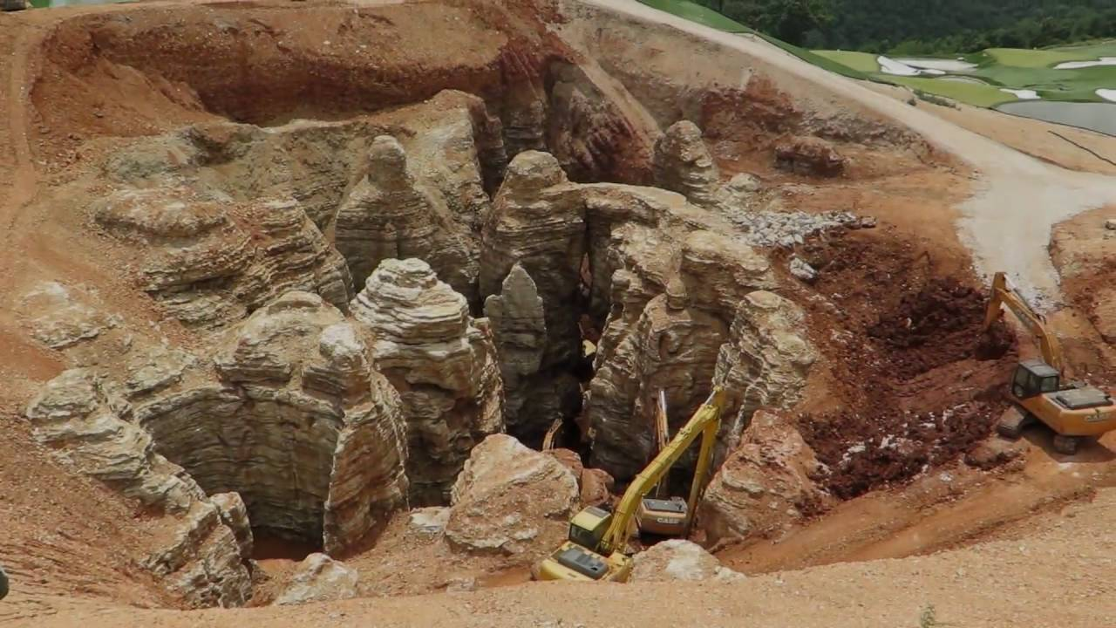

Figure 18. Sinkhole at Top of the Rock in southwestern Taney County, Missouri, as it looked after excavation of a considerable amount of surficial material. The project reveals in a striking manner the pinnacle and cutter character of the top of karsted carbonate sedimentary bedrock in the Springfield plateau physiographic area.
Image from https://www.youtube.com/watch?v=MODhYNVqaMQ, last accessed on May 23, 2017.

The geologic setting of Top of the Rock Golf Course is a typical Ozark ridge and adjacent hillslopes. The underlying bedrock is composed of Mississippian-age Reeds Spring Formation characterized by alternating layers of limestone and chert. The formation in this area is further characterized by enlarged joints created by solution weathering, resulting in a bedrock surface of deep, narrow cutters and adjacent pinnacles with horizontal solution-enlarged conduits developed near the base of weathering. Draped over this jagged bedrock surface is highly weathered, thick, chert-clay residuum derived from dissolution of carbonate units.
The northern portion of the golf course and the adjacent U.S. Route 65 are constructed over a large, elongated sinkhole that trends northeast–southwest (Figure 19). Portions of the sinkhole were remediated to allow for construction of U.S. 65. The Top of the Rock sinkhole collapse is located about 1,000 feet south of the previously identified elongated sink structure.
Three caves have been mapped in the immediate vicinity of the golf course. The caves are aligned northeast–southwest, similar to the elongated trend of the collapse structure. One of the caves, located on Top of the Rock Golf Course property, is known as Johnny L Cave, after Johnny Morris who owns Bass Pro Shops. Water was reported gushing from this cave shortly after the collapse of the decorative pond.
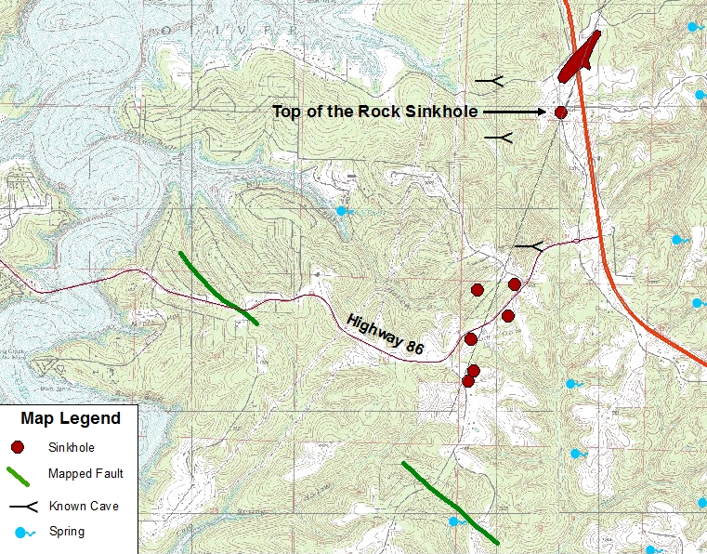

Figure 19. Generalized map of the Top of the Rock area, southwestern Taney County, Missouri.

Curiosity and expectations that the collapse feature and the cave are somehow connected prompted Mr. Morris to excavate the Top of the Rock sinkhole, rather than attempt remediation with a stable plug (Figure 18). Mr. Morris’ goal is to find an underground connection between the sinkhole and a larger cave system tied to Johnny L Cave. Reports from Top of the Rock state that excavation crews have removed more than 38,000 truckloads of material (over 533,000 cubic yards) expanding it to 270 feet wide, 340 feet long, and 185 feet deep. Time will tell whether a connection between the sinkhole and the cave is found. Regardless, the excavation has exposed a textbook example of the effects of solution weathering on limestone and revealed an erratic karst surface hidden beneath the thick cover of unconsolidated material which blankets the Missouri Ozarks.

■ ■ ■

Third Leg of Road Log — Return to Branson, Missouri

Numbers in left column are travel distances in statute miles. Red numbers are mile markers alongside federal routes. Features pointed out in this log can be viewed using Google Street View and associated aerial imagery.

0.0 Exit Top of the Rock at round-a-bout and travel east on Missouri Route 86 a short distance.
0.2 Turn left onto U.S. Route 65 and travel north towards Branson.
9.5 12.2. Exit right at Branson Landing Boulevard exit. Then, turn right onto Branson Landing Boulevard.
10.7 Turn right onto East Main Street and cross railroad track.
10.8 Turn left onto South Sycamore Street. Turn left into Branson Convention Center.

■ ■ ■
Post-Meeting Field Trip, June 15, 2017

■ ■ ■

Geology Float Trip on Buffalo National River, Northern Arkansas

■ ■ ■

Figure 20. Map for Post-Meeting Drive Route from Branson to Buffalo National River.

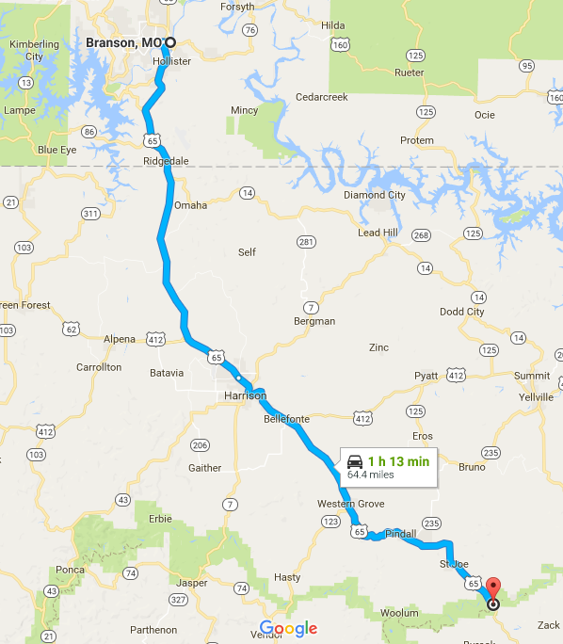
Buffalo Natl. River
ARKANSAS
MISSOURI
N

Geology Float Trip on Buffalo National River, Northern Arkansas
by
Justin G. Davis
Missouri Geological Survey, Rolla, Missouri

Introduction
This float trip will be on a 5.5-mile-long stretch of the Buffalo River in northern Arkansas (Figures 21 and 22). This stretch is one of the most popular floats on the river. By congressional act in 1972, the 135-mile-long lower portion of the Buffalo was designated the Buffalo National River, which is owned by the federal government and managed by the National Park Service. The Buffalo National River has the distinction of being America’s first National River, and this national status (1) precludes the river from being dammed, (2) limits development of a sizeable amount of land flanking the river and (3) serves to preserve and protect a primitive natural setting.

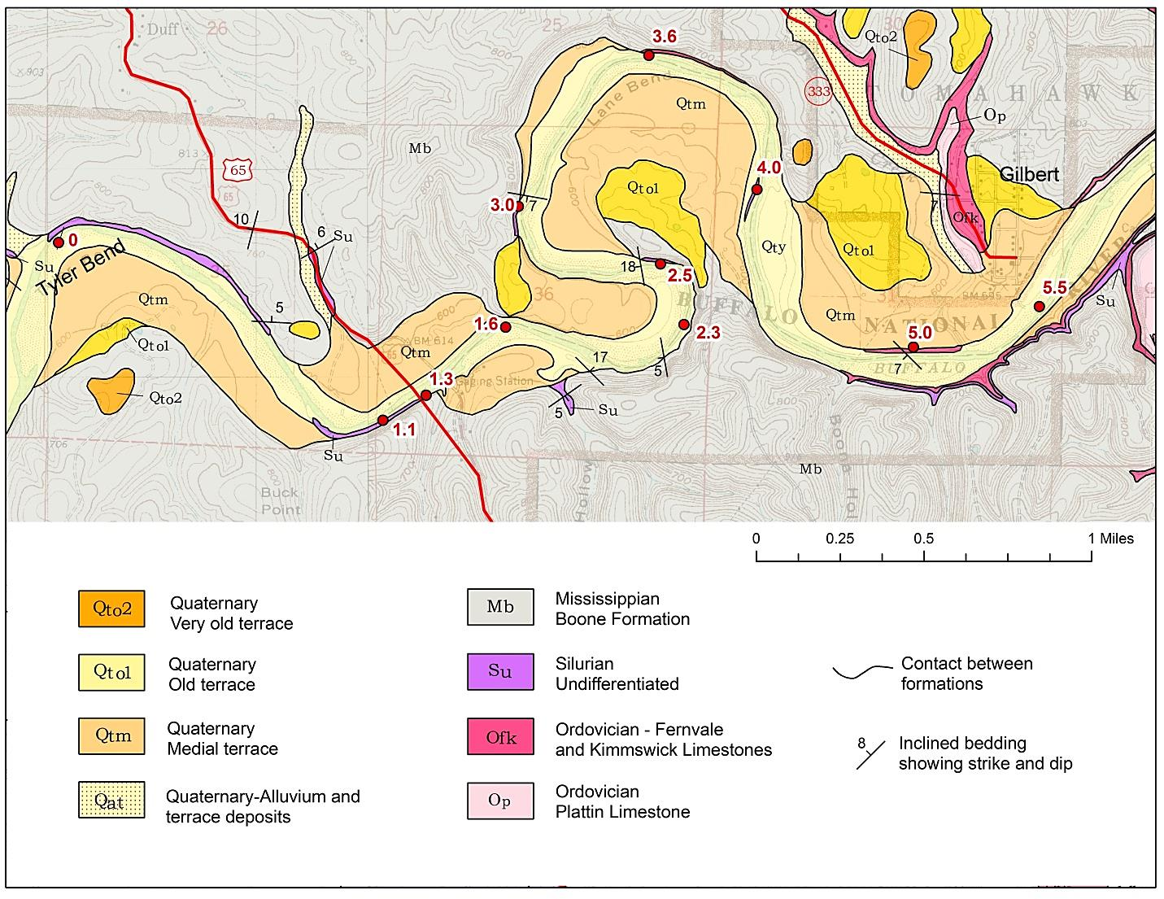
N
Figure 21. Map showing 5.5-mile-long float trip route on the Buffalo National River from “put in” at Tyler Bend (green star) to “take out” at Gilbert (red star). Noteworthy exposures of Ordovician, Silurian and Mississippian bedrock along the float route are shown. Provided by Arkansas Geological Survey.

Physiographic Setting
The Buffalo River is 153 miles long and has its headwaters in the Boston Mountains, which is the southernmost and the highest portion of the Ozark Plateau (Figure 22). The river flows north out of the Boston Mountains and then flows east along and then across the Springfield Plateau to its confluence with the White River at the transition from the Springfield Plateau to the Salem Plateau regions of the Ozark Plateau.

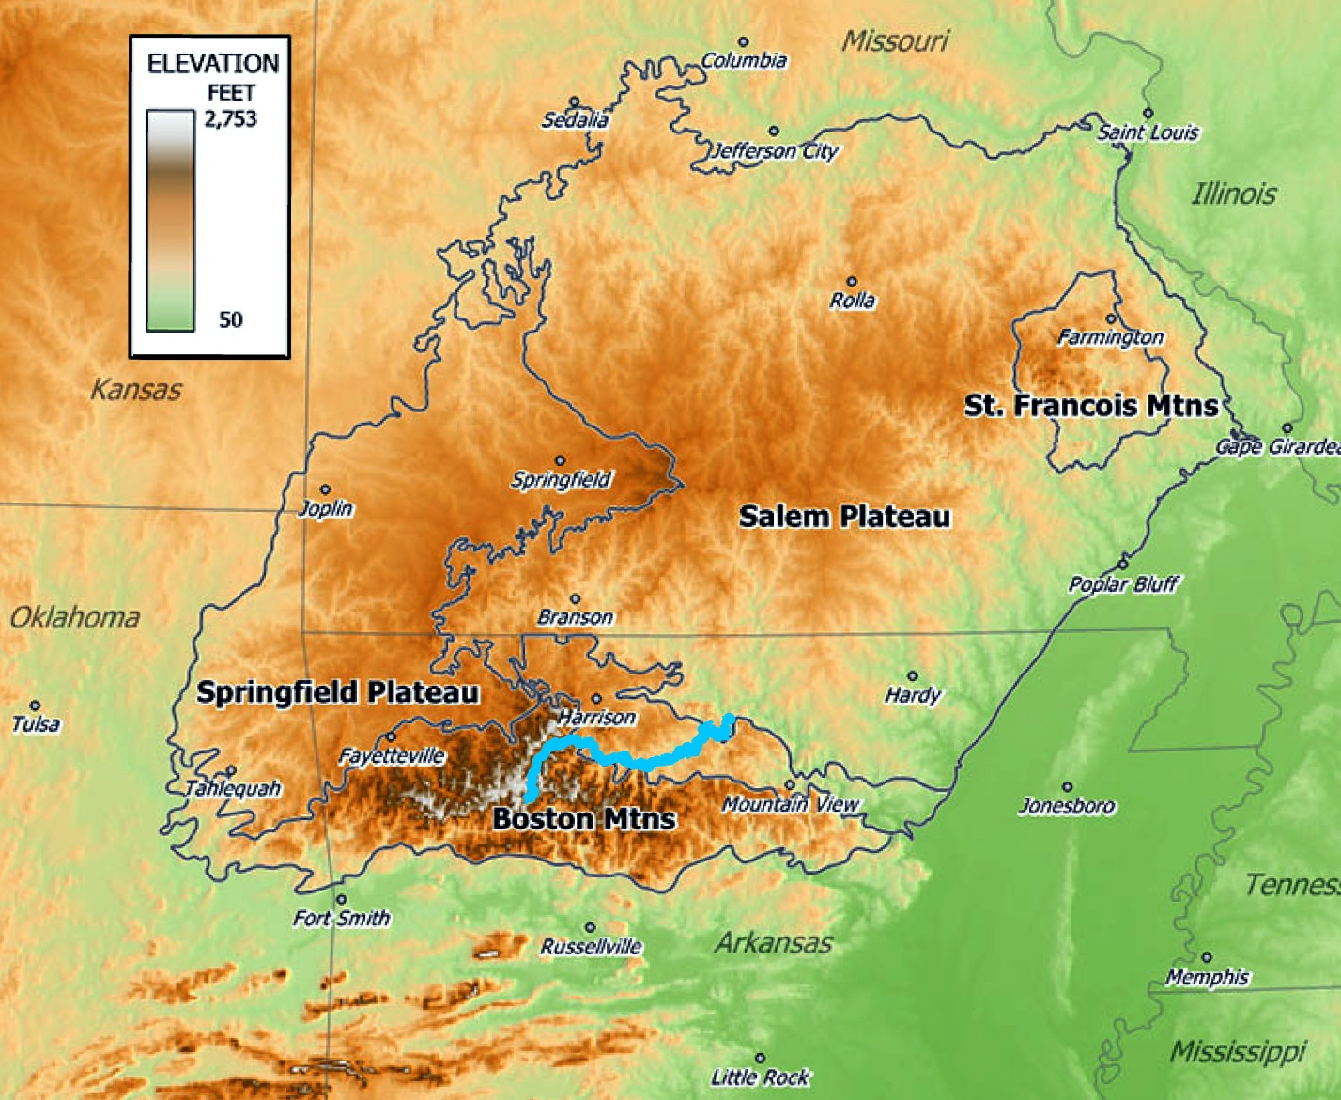
OZARK
PLATEAU
100 MILES
N

Figure 22. Physiographic map showing location of the 153-mile-long Buffalo River (blue line) in the southern portion of the Ozark Plateau, which comprises the Boston Mountains, Springfield Plateau and Salem Plateau. Buffalo River confluence with White River is at east end of blue line. Red circle marks location of float from Tyler Bend to Gilbert.
Modified from Wikipedia public domain file https://en.wikipedia.org/wiki/Ozarks#/media/ File:OzarkRelief.jpg accessed April 24, 2017.

Geology
Sedimentary strata ranging in age from Ordovician Mohawkian Plattin Limestone, to Ordovician Cincinnatian Fernvale Limestone and Cason Formation, to Silurian limestones, to Mississippian Kinderhookian/Osagean Boone Formation limestone are exposed along the float route (Figures 21 and 23; Table 2). All units are unconformable with one another. The Ordovician Mohawkian St. Peter Sandstone does not crop out along our route; however, it is exposed downstream (east) from Gilbert. Silurian limestones include, from bottom to top, the Brassfield, St. Clair, and Lafferty Limestones. The Brassfield and St. Clair are fine- to medium-crystalline and contain fossils. The two can be difficult to distinguish, although the Brassfield is sometimes more pinkish in color. The Lafferty is grey to reddish-grey micritic limestone that contains few fossils.
As is typical for the Ozark Plateau, the strata are essentially flat lying, with localized areas of conspicuously dipping strata that are associated with faults and karst features.

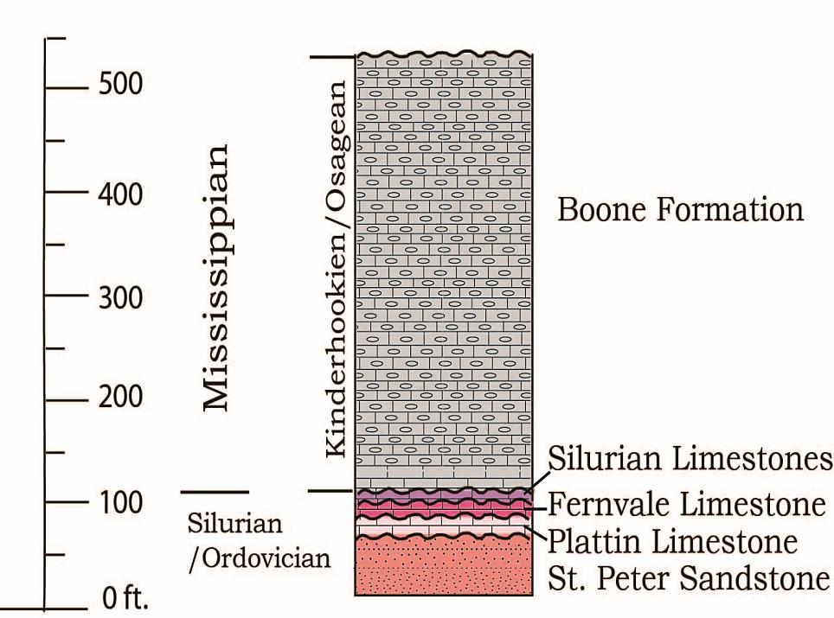

Figure 23. Stratigraphic column for bedrock that crops out along the Buffalo National River. The St. Peter Sandstone does not crop out from Tyler Bend to Gilbert, but does crop out farther downstream. Provided by Arkansas Geological Survey.

Table 2. Lithostratigraphic nomenclature: Arkansas vs. Missouri

System Subsystem | Series Stage | Lithostratigraphic Nomenclature
System Subsystem | Series Stage | Arkansas |  | Missouri
Carboniferous  Mississippian | Middle Mississippian  Osagean |  |  | Burlington-Keokuk Ls.
Carboniferous  Mississippian | Middle Mississippian  Osagean |  |  | Reeds Spring-Elsey F.
Carboniferous  Mississippian | Middle Mississippian  Osagean | Boone F. | St. Joe Ls. Mbr. | Pierson Ls.
Carboniferous  Mississippian | Lower Mississippian  Kinderhookian | Boone F. | St. Joe Ls. Mbr. | Northview F.
 |  |  |  | Compton Ls.
Carboniferous  Mississippian | Lower Mississippian  Kinderhookian | “basal Mississippian ss.” |  | Bachelor F.
Silurian | Cayugan | Lafferty Ls. |  | Bainbridge F.
Silurian | Niagaran | St. Clair Ls. |  | Bainbridge F.
Silurian | Alexandrian | Brassfield Ls. |  | Sexton Creek Ls.
Ordovician | Cincinnatian | Cason F. |  | Maquoketa Gr.
Ordovician | Cincinnatian | Fernvale Ls. |  | Cape Ls.
Ordovician | Mohawkian | Plattin Ls.
Ordovician | Mohawkian | St. Peter Ss.

Karst and Aquifers
The following extracts from Hudson et al. (2011, p. 191, 195–197) provide a succinct overview of karst conditions in the Buffalo River drainage basin.
“Karst landscapes are well expressed at Buffalo National River…. The watershed for the Buffalo River and adjacent areas contains abundant caves, sinkholes, losing streams, and springs that are linked in karst hydrologic systems.
“…the thick limestone interval of the Mississippian Boone Formation developed kart systems from the interchange of surface and groundwater via recharge from sinkholes and losing-stream segments and discharge at springs…. An unpublished NPS inventory of caves within the park demonstrates that Boone Formation is the dominant host of caves…. An inventory of springs within the Mill Creek subbasin of the Buffalo River demonstrates a strong frequency maximum at or near the basal contact of the St. Joe Limestone Member of the Boone Formation.”
Hudson et al. (2011, p. 195) deemed that “Ordovician rocks comprise the upper part of the Ozark aquifer” in the Buffalo River basin and that the Boone Formation along with its St. Joe Limestone Member comprise the overlying Springfield Plateau aquifer. However, they did not address the Silurian stratal package; therefore, it is not certain to which aquifer Silurian strata should be assigned.

River Log — Rewritten from Smart and Doerr (no date) with permission from Arkansas Geological Survey. Red numbers are float distances in statute miles.

0.0 Tyler Bend — The bottom third of the bluff consists of Silurian limestone that Smart and Doerr (no date) assigned to the Brassfield Limestone (Figure 24). The Silurian is unconformably overlain by fine-grained “basal Mississippian sandstone” that is unconformably overlain by red to pink, thin-bedded, argillaceous, crinoidal limestone of the Kinderhookian/Osagean St. Joe Member of the Boone Formation. The St. Joe is unconformably overlain by a thick section of Osagean cherty limestone of the Boone Formation.

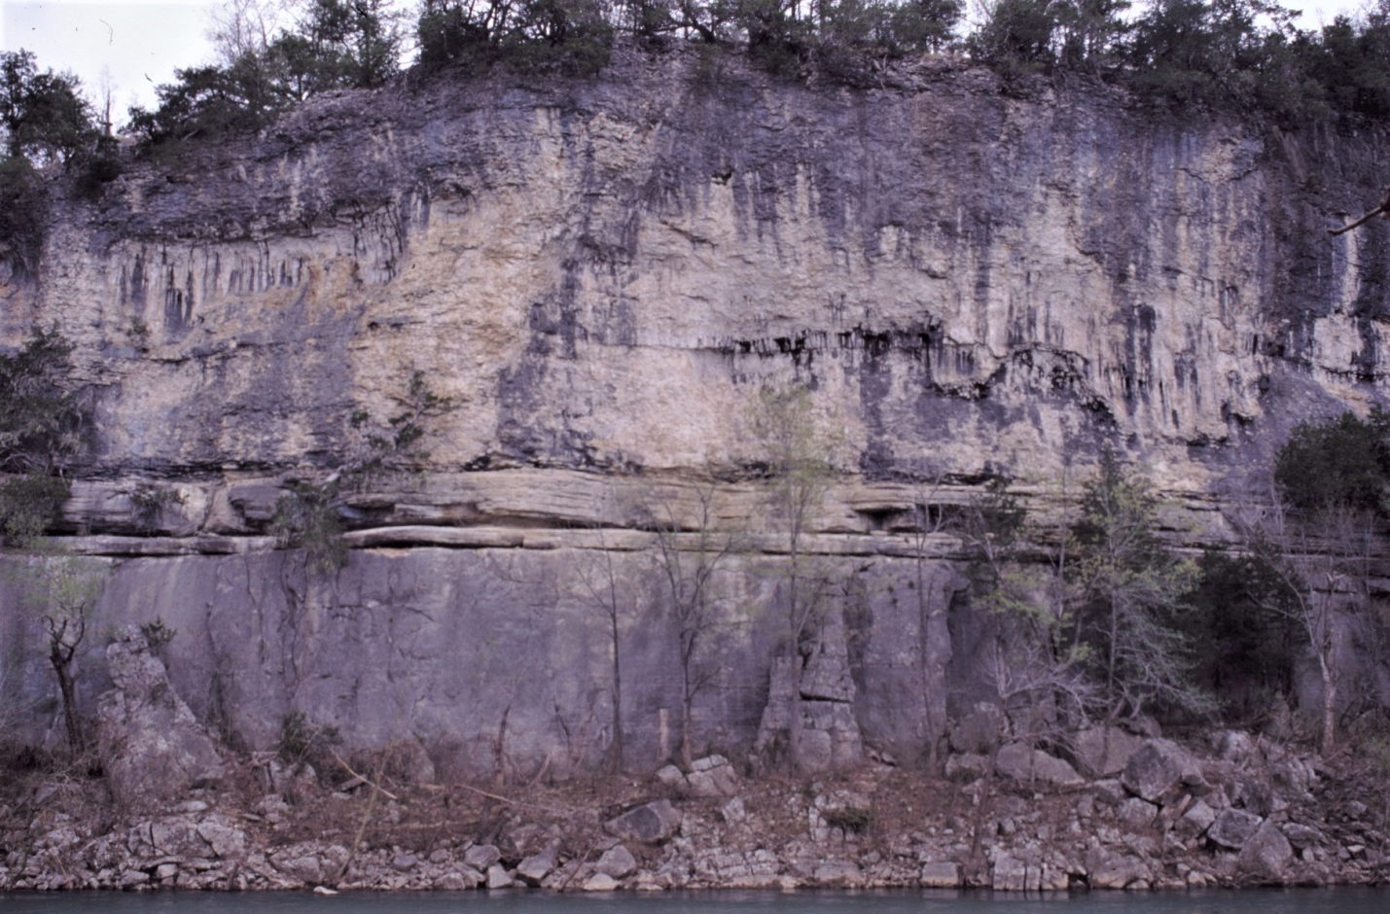
St. Joe Ls. Mbr.
“basal Miss. ss.”
B r a s s f i e l d L s.
B O O N E F.

Figure 24. Bedrock formations exposed in bluff at Tyler Bend. Photograph from Arkansas Geological Survey.
1.1 McMahan Bluff — Just upstream of the U.S. Route 65 bridge is McMahan Bluff. The contact between Silurian limestone and overlying “basal Mississippian sandstone” is at or near river level when the river is at normal stage. Depending on river stage, this is a good place to stop and examine these two rock units.
The sandstone has a “salt and pepper” appearance and is composed predominantly of well-rounded, fine- to medium-grained quartz sand. Opaque grains in the sandstone are likely phosphatic in composition. The sandstone is approximately 2–4 feet thick at this location and is overlain by approximately 10 feet of St. Joe Limestone. The contact with the overlying Boone, which makes up the remainder of the bluff, is likely to be covered with vegetation during warm months.

1.3 U.S. Geological Survey Gauging station — The gauge is located on the south bank, just east of the Route 65 bridge. Real-time river level and discharge updates, along with histograms of historical data from this station, are available on the USGS website.

1.5 Approach to Grinders Ferry — A portion of the cut bank at Grinders Ferry is composed of Quaternary alluvium and terrace deposits (Figure 25). These unconsolidated deposits are easily eroded along the cut bank. In 2005, Park Service employees began efforts to reduce erosion of the cut bank. They installed a series of revetments made from trees fastened securely into the river bank (Figure 25). The trees serve to protect the unconsolidated deposits from the erosive power of the river. The revetments should provide slope stability and promote plant growth on the cut bank.

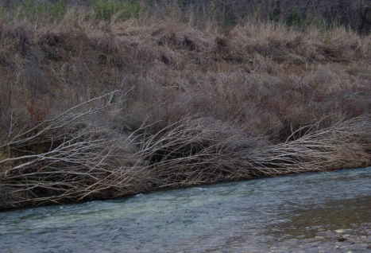
Q u a t e r n a r y d e p o s I t s

Figure 25. Park Service placed tree revetments to mitigate erosion of unconsolidated Quaternary bank deposits. From Smart and Doerr (no date).

1.6 Grinders Ferry — A small exposure of greenish-grey to black shale of Upper Ordovician Cason Formation is visible beneath reentrant at the base of the bluff at Grinders Ferry when river stage is not too high (Figure 26). Unconformably above the Cason is 40–50 feet of Silurian limestone in which fossils are common. Other interesting features inside the reentrant include calcite-filled vugs and sandstone-filled veins, the latter being a few millimeters to a few centimeters wide.
The Silurian Brassfield, St. Clair and Lafferty Limestones are reportedly exposed in this bluff; however, they are difficult to distinguish, even upon careful examination and sampling. Also, approximately 3–5 feet of “basal Mississippian sandstone” overlies the Silurian, followed by approximately 10 feet of thin-bedded St. Joe Limestone. Additional Boone Formation is present on top of the hill and cannot be seen from river level.

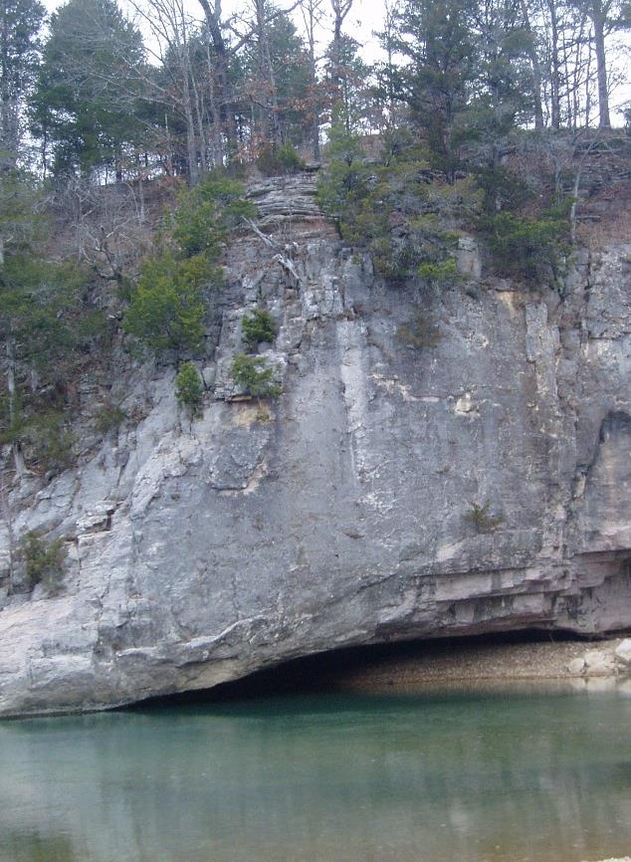
Ordovician Cason F. in reentrant
Mississippian
Silurian

Figure 26. Bluff at Grinders Ferry showing reentrant. See text for further explanation. From Smart and Doerr (no date).

2.3 Shine Eye Bend — Conspicuously visible are two large, very cherty boulders of Boone Formation that fell from high off the bluff and came to rest in water at the base of the bluff (Figure 27). The boulders provide a good opportunity to examine the cherty character of Boone Formation limestone.
Silurian limestone is exposed at the base of the bluff at river level. It is overlain with marked disconformity by undulating “basal Mississippian sandstone” that is 5–6 feet thick, and this thickness exceeds that of the sandstone at any other location on the river. Phosphate pebbles up to 4 cm in size are present in the sandstone, which also exhibits disturbed bedding that can be attributed to soft sediment deformation. Thin-bedded St. Joe Limestone, approximately 10 feet thick, is present above the “basal Mississippian sandstone.” This is a good place to examine the crinoidal character of the St. Joe, which has been observed to host pyrite crystals at this location. The St. Joe is overlain by thick cherty Boone that is the source of the boulders that fell into the river.

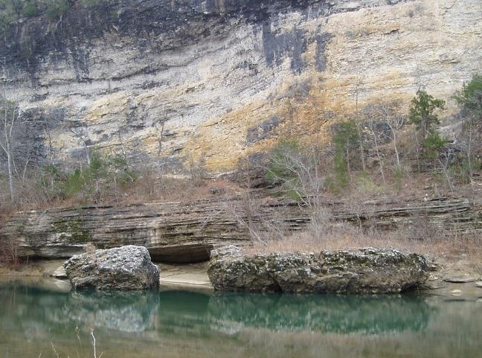

Figure 27. Fallen boulders of upper Boone Formation resting in river at Shine Eye Bend. See text for further explanation. From Smart and Doerr (no date).

2.5 Shine Eye Bluff — Thin- to medium-bedded Silurian (probably Lafferty) limestone that strikes N 10° W and dips 18° E is angularly overlain by relatively flat-lying “basal Mississippian sandstone” and St. Joe Limestone Member of the Boone Formation (Figure 28). Downstream toward the end of the bluff, older Silurian units come into view above river level, and the Brassfield Limestone eventually forms the lower 30–40 feet of the bluff.

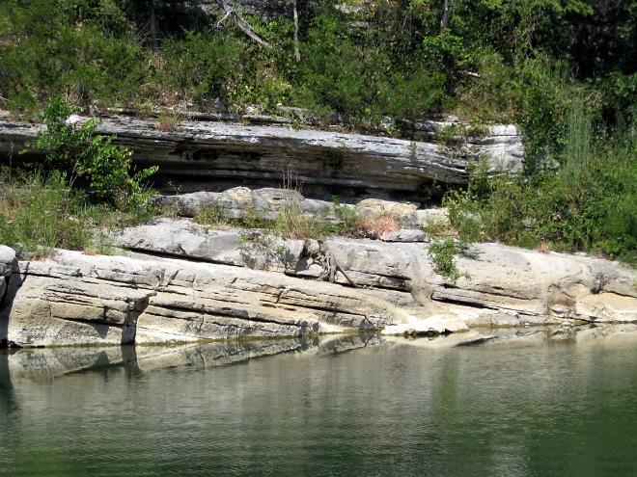

Figure 28. Silurian (probably Lafferty) limestone is angularly overlain by Mississippian St. Joe Limestone Member of Boone Formation in the upstream portion of Shine Eye Bluff. See text for further explanation. From Smart and Doerr (no date).

3.0 Lane Bluff — The first cut bank in Lane Bluff provides the last large exposure the Silurian Brassfield Limestone. If the water level is not too high nor the vegetation too thick, this is a good area to get out and walk beneath the overhang and examine some of the features in this limestone. Calcite-filled vugs, veins, and fossils are common in the Brassfield at this exposure.

3.6 Long Bottom Bluff — Ordovician units make their first appearance at river level. The Fernvale Limestone emerges from the river bed and crops out approximately 20 feet above river level. Silurian units have thinned to just a few feet. The “basal Mississippian sandstone” is approximately 3 feet thick, followed by about 15 feet of St. Joe Limestone. The Boone comprises the upper 5–8 feet of the bluff. The Buffalo River Trail (BRT) traverses the top of this bluff on its way into Gilbert.

4.0 The Fernvale drops back below river level on the downstream end of Long Bottom Bluff. Approximately 5 feet of Silurian strata are exposed in the banks of the river where Quaternary material is not covering bedrock. The exposure thickens downstream, where approximately 15–20 feet of Silurian strata is overlain by 1–2 feet of “basal Mississippian sandstone” and 5–10 feet of St. Joe Limestone.

5.0 This is the final exposure of Silurian and Mississippian rocks before heading into Gilbert. The strata strike N 45° W and dip 7° SW. As we head northeast in a structurally up-dip direction towards Gilbert, underlying Ordovician strata rise successively into view. The Fernvale Limestone flanks the river just upstream from the mouth of Dry Creek. At the mouth of Dry Creek, the Fernvale and its contact with underlying Plattin Limestone are exposed to view.

5.5 Gilbert Gravel Bar. Ordovician Plattin Limestone flanks the river and also crops out at the old town perennial Gilbert Spring just below the Old Rail Road grade trail that heads east out of Gilbert. Ordovician units continue to crop out downstream from Gilbert, including excellent exposures of the Ordovician Mohawkian St. Peter Sandstone and underlying Ordovician Whiterockian Everton Formation dolomite.

Compendium of References Cited
Anonymous, 1906, Phenix Stone and Lime Co. Rock Products, v. 6, n. 1, December 5, p. 23.
Anonymous, 1916, Notes from the stone fields. Stone, v. 37, January–December, p. 540–541.
Anonymous, 1923, Phenix, Greene County, Missouri; the Phenix Marble Company power plant. Stone, v. 44, March, p. 155–156, 218.
Anonymous, 1927, Marble quarry at Phenix, Mo. The Frisco Employes’ [sic] Magazine, v. 5, December, p. 13 and 25.
Anonymous, 2016, History of Silver Springs, Sequiota parks in Springfield. Buffalo Reflex magazine, February 16, accessed on-line April 19, 2017, at http://buffaloreflex.com/heritage/history-of-silver-springs-sequiota-parks-in-springfield/article_dfd0cf68-d4e7-11e5-b83a-6f35401ca74f.html.
Anonymous, 2017, Marvel Cave. Silver Dollar City website accessed on April 7, 2017, at http://www.silverdollarcity.com/theme-park/Attractions/Rides/Marvel-Cave.
Bretz, J H., 1956, Caves of Missouri. Missouri Department of Business and Administration, Division of Geological Survey and Water Resources, Volume 39, 2nd Series, 490 p.
Buckley, E.R., Buehler, H.A., The quarrying industry of Missouri. Missouri Bureau of Geology and Mines, Volume 2 (2nd Series). 371 p.
Bullard, L., Thomson, K.C., and Vandike, J.E., 2001, The springs of Greene County. Missouri Department of Natural Resources, Geological Survey and Resource Assessment Division, Water Resources Report 68, 120 p.
Hinchey, N.S., 1946, Missouri marble. Missouri Geological Survey and Water Resources, Report of Investigations 3, 47 p.
Hudson, M.R., Turner, K.J., and Bitting, C., 2011, Field trip guide—Geology and karst landscapes of the Buffalo National River area, northern Arkansas. U.S. Geological, Scientific Investigations Report 2011–5031, p. 191–212.
Missouri Geological Survey, 2017, GeoSTRAT – Geosciences Technical Resource Assessment Tool. Missouri Department of Natural Resources, Missouri Geological Survey On-Line Internet Application, http://dnr.mo.gov/geology/geostrat.htm.
Prince, S. F., 1938, Marvel Caverns, Stone County, surveys and drawings. One sheet map in Missouri Speleology Society Files.
Plymate, T.G., Evans, K.R., Thomson, K.C., Miller, J.F., Rovey, C.W. II, Davis, G.H., and Cutler, J., 2004, Ordovician and Mississippian stratigraphy and structural geology of the Springfield-Branson area, southwestern Missouri, in Plymate, T.G., editor, Association of Missouri Geologists field trip guidebook 50th annual meeting. Missouri Department of Natural Resources, Geological Survey and Resource Assessment Division, Report of Investigations 75, p. 43–62.
Rueff, A.W., 1991, Chemical and physical properties of selected stone resources in southwest Missouri, 2nd edition. Missouri Department of Natural Resources, Division of Geology and Land Survey, Open File Report OFR-91-86-MR, 154 p.
Searight, T.K., 1960a, Untitled bedrock geologic map. Missouri Geological Survey, Geologic Map SP6032, 1 sheet.
Searight, T.K., 1960b, Untitled bedrock geologic map. Missouri Geological Survey, Geologic Map SP6036, 1 sheet.
Shepard, E.M., 1898, A report on Greene County, in Keyes, C.R., Reports on areal geology, Part 1. Missouri Geological Survey, Volume 12, 245+IV p.
Smart, E., and Doerr, E., no date, River log of Tyler Bend to Gilbert. Arkansas Geological Survey, Unpublished Manuscript.
Thompson, T.L., 1986, Paleozoic succession in Missouri, Part 4—Mississippian System. Missouri Department of Natural Resources, Division of Geology and Land Survey, Report of Investigations 70, Part 4, 182 p.
Thompson, T.L., 1991, Paleozoic succession in Missouri, Part 2—Ordovician System. Missouri Department of Natural Resources, Division of Geology and Land Survey, Report of Investigations 70, Part 2, 282 p.
Thompson, T.L., 2001, Lexicon of stratigraphic nomenclature in Missouri. Missouri Department of Natural Resources, Division of Geology and Land Survey, Report of Investigations 73, 367 p.
Thomson, K.C., 1982, Untitled bedrock geologic map. Missouri Geological Survey, Geologic Map SP8250, 1 sheet.
Thomson, K.C., 1983, Untitled bedrock geologic map. Missouri Geological Survey, Geologic Map SP8378, 1 sheet.
Vineyard, J.D., and Fellows, L. D., 1967, Guidebook to the geology between Springfield and Branson, Missouri, emphasizing stratigraphy and cavern development. Missouri Department of Business and Administration, Division of Geological Survey and Water Resources, Report of Investigations 37, 39 p.
Vineyard, J.D., and Feder, G.L., 1982, Springs of Missouri. Missouri Department of Natural Resources, Division of Geology and Land Survey, Water Resources Report 29 Revised, 212 p.
Wheeler, H.A., 1892, Missouri Geological Survey Field Note Book 211, 58 p.

Appendix

Generalized Geologic Map of Missouri

Mineral Resources in Missouri

Missouri Groundwater

Major Structural Features of Missouri

Physiographic Regions of Missouri

Surface Elevation Map of Missouri

Surficial Materials Map of Missouri

Topographic Relief Map of Missouri

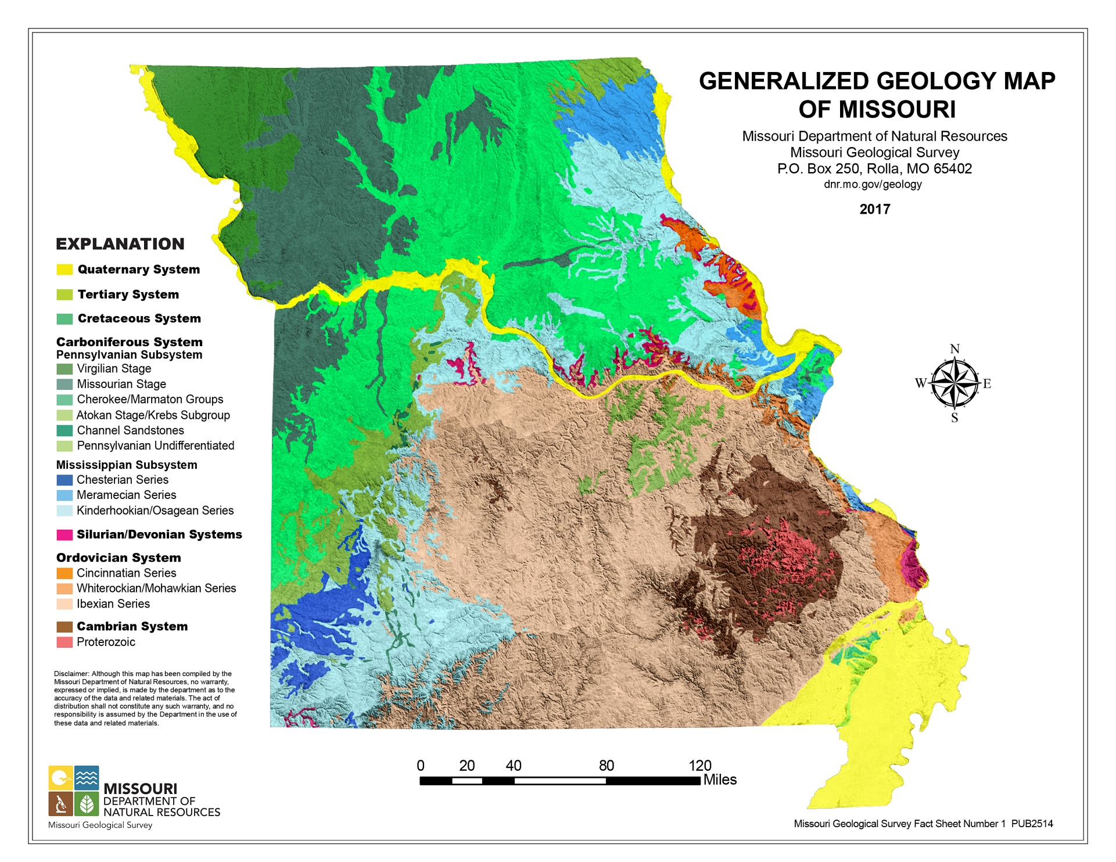

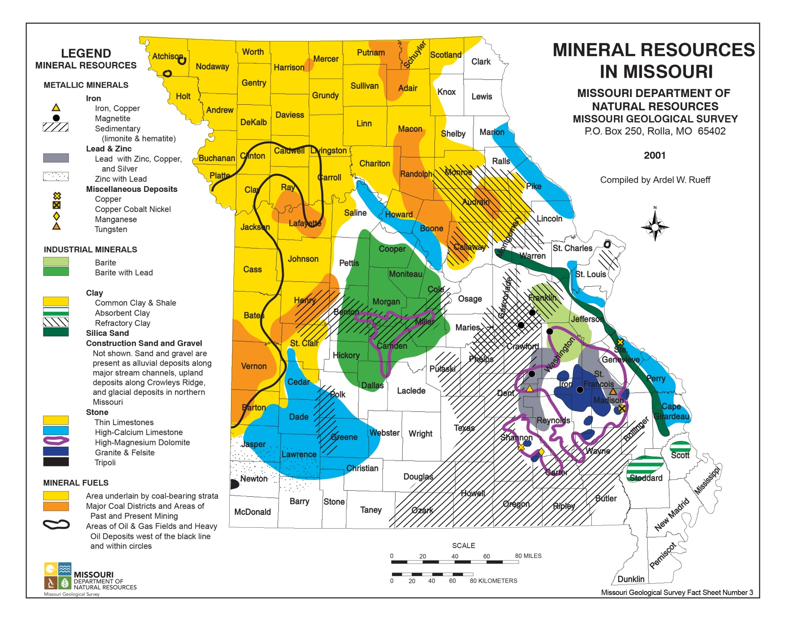

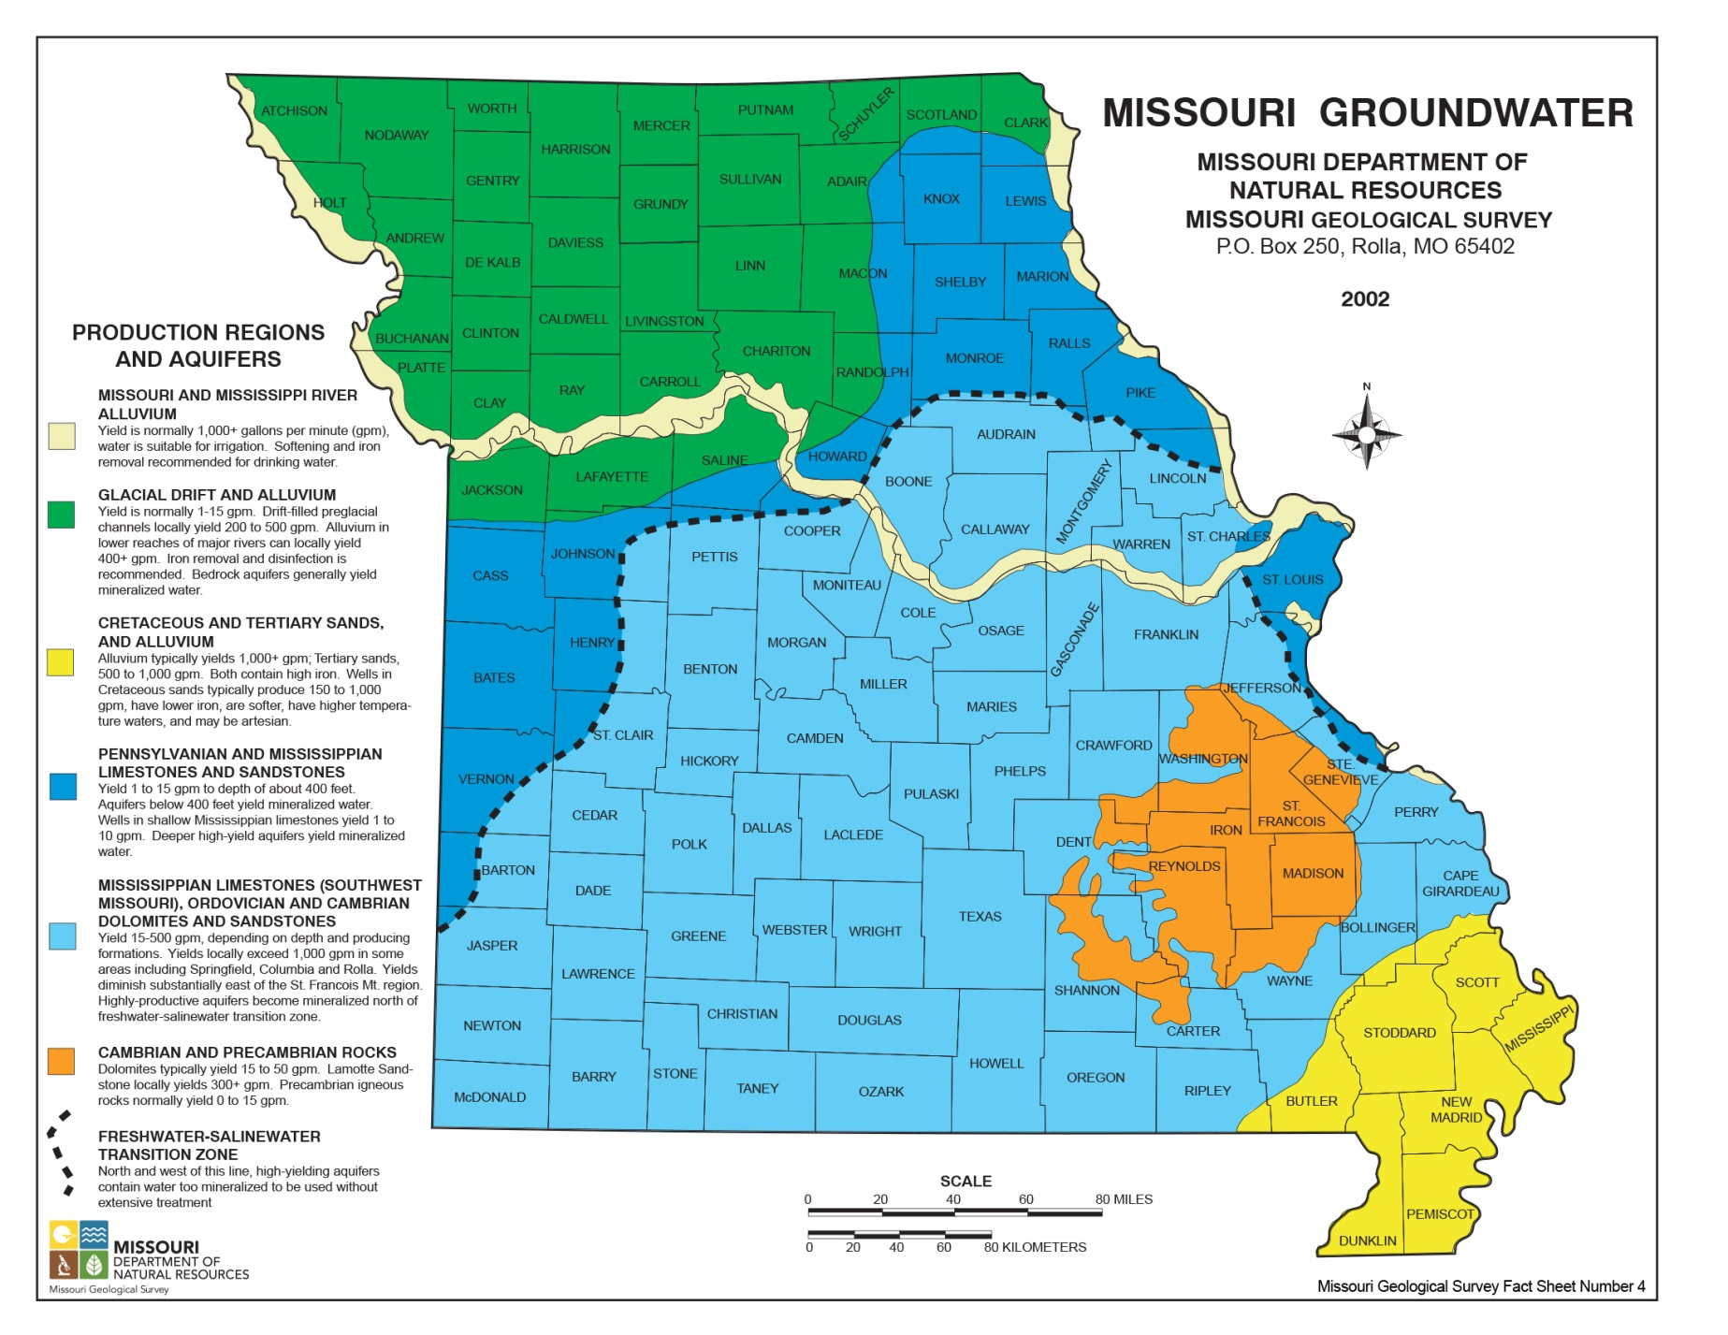

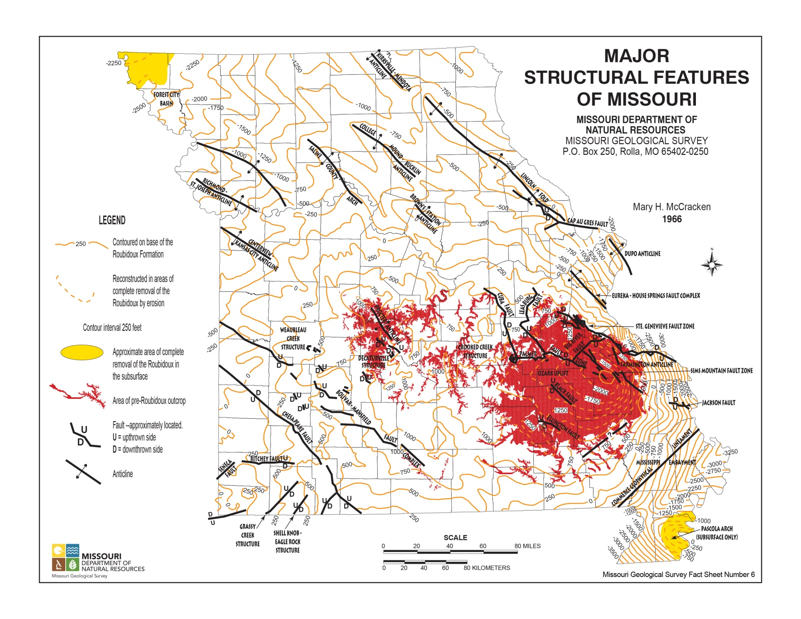

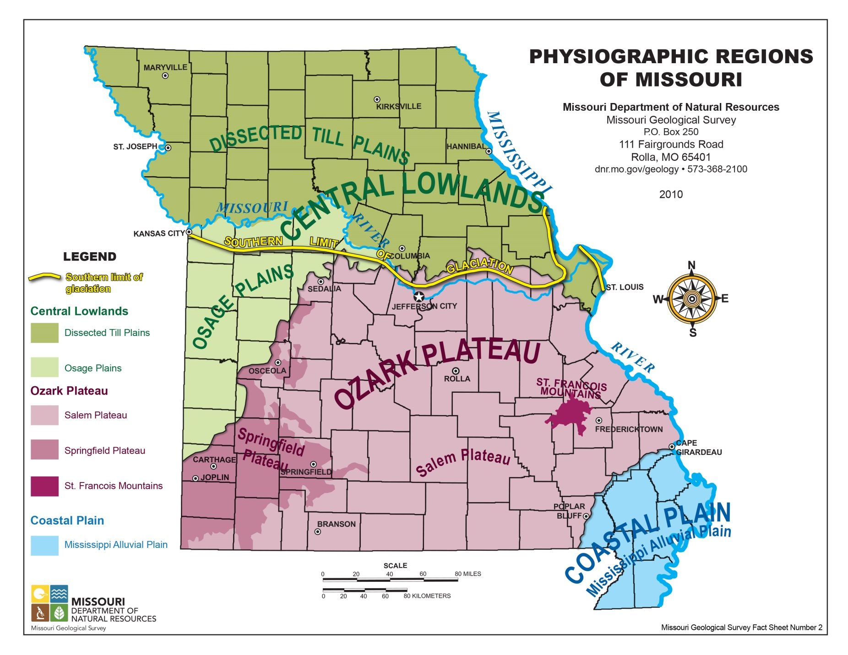

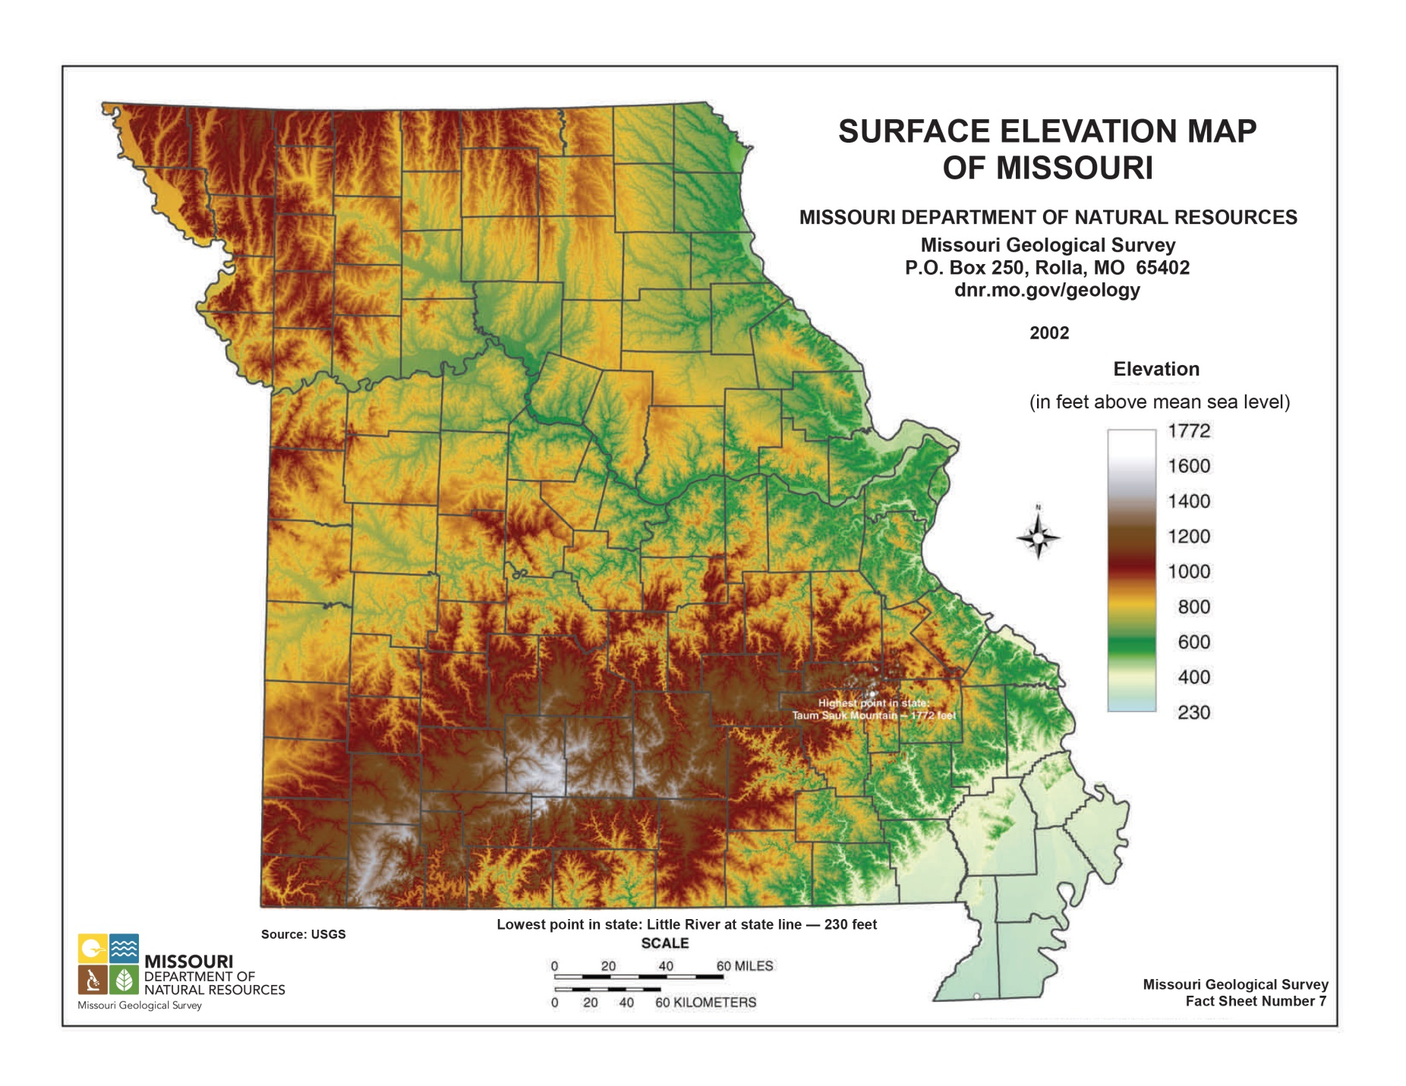

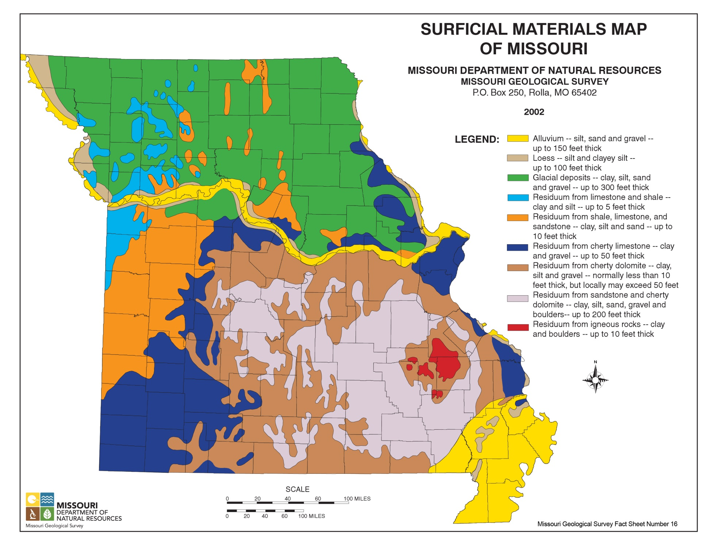

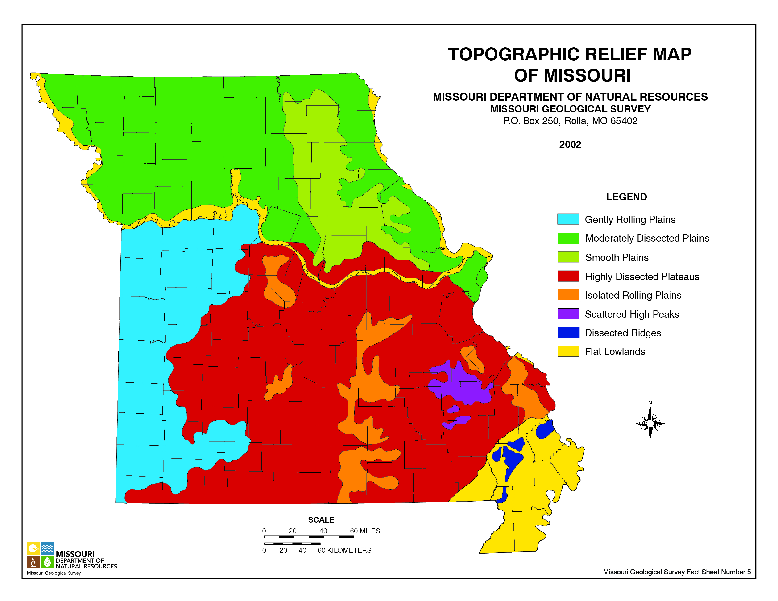

N O T E S P A G E





MISSOURI GEOLOGICAL SURVEY
Special Publication No. 12
Guidebook No. 27

